Silvan Reservoir Storm Damage Remediation Project:

Flora and fauna assessment

©2021 Ecology Australia Pty Ltd
This publication is copyright. It may only be used in accordance with the agreed terms of the commission. Except as provided for by the Copyright Act 1968, no part of this publication may be reproduced, stored in a retrieval system, or transmitted in any form or by any means, without prior written permission from Ecology Australia Pty Ltd.
Document information
This is a controlled document. Details of the document ownership, distribution, status and revision history are listed below.
All comments or requests for changes to content should be addressed to the document owner.

Owner | Ecology Australia Pty Ltd
Project | 21-036
Author | Marty White, Alice Ewing, Chris Bloink
File | Final Report Flora, Fauna and Native Vegetation Impact Assessment Silvan Reservoir 2021_12_10
Bioregion | Highlands – Southern Fall
Distribution | David Fisher | Melbourne Water

Document History
Status | Changes | Author | Reviewer | Date
Draft 1 | First draft | M White, A Ewing, C Bloink | C Bloink | 26/11/2021
Final | Minor amendments | M White, A Ewing, C Bloink | M White | 10/12/2021

Cover photo:

Contents
Acknowledgments 6
1 Introduction 7
2 Study Area 8
2.1 Land-use 8
2.2 Natural Values 8
2.3 Critical Water Infrastructure – Silvan Dam 8
2.4 Bushfire Risk Mitigation 8
3 Summary of proposed remediation works 10
4 Methods 12
4.1 Definitions 12
4.1.1 Likelihood of occurrence 12
4.1.2 Likelihood of significant impact 12
4.2 Database review 13
4.3 Site inspection 13
4.4 Limitations 14
5 Results 16
5.1 Flora assessment 16
5.1.1 Landscape context 16
5.2 Fauna habitat 20
5.2.1 Deep water and shallow margins 20
5.2.2 Damp / Lowland Forest- high density shrub and groundcover 20
5.2.3 Roosting Habitat 20
5.2.4 Stoneyford Creek headwaters 21
5.3 Threatened species and communities 21
5.3.1 Threatened ecological communities 21
5.3.2 Threatened Fauna Species 22
5.3.3 Threatened Flora Species 29
6 Assessment of significant impacts to Matters of National Environmental Significance 32
6.1 Summary of the relevant Matters of National Environmental Significance 32
6.1.1 Threatened communities 32
6.1.2 Threatened and migratory species 32
6.2 Broad-toothed Rat (Vulnerable – EPBC Act) 35
6.2.1 Species ecology, local habitat information and threats 35
6.2.2 Significant Impact Criteria Assessment 36
6.3 Southern Greater Glider (Vulnerable – EPBC Act) 39
6.3.1 Species ecology, local habitat information and threats 39
6.3.2 Significant Impact Criteria Assessment 39
7 Risk Assessment of significant protected Flora and Fauna under the FFG Act 44
7.1 Burrowing crayfish – Engaeus spp. 45
7.2 Amphipods – Austrogammurus spp. 46
7.3 Large forest owl species – Sooty Owl and Powerful Owl 47
7.4 Powelltown Correa – Correa reflexa var. lobata 47
7.5 Victorian Flat-pea – Platylobium reflexum 48
7.6 Orchids 48
8 Recommendations 54
9 References 57
10 Glossary 59

Tables
Table 1 Description of likelihood classifications. 12
Table 2. All threatened fauna species (FFG and EPBC Acts) that are present or have a moderate or high likelihood of occurrence at Silvan Reservoir. 24
Table 3 Nationally significant threatened fauna species with moderate or higher likelihood of occurrence. 26
Table 4 Nationally Significant Migratory or Marine Species with a moderate or high likelihood of occurrence. 27
Table 5 State significant species, with moderate or higher likelihood of occurrence at Silvan Reservoir. These are the species that have not already been included in the Nationally Significant species lists presented in Table 3 and Table 4. 28
Table 6 Threatened Flora of Moderate or high likelihood of occurrence at Silvan Reservoir. 31
Table 7 Likelihood of significant impact from the proposed storm damage remediation works on Matters of National Environmental Significance under the EPBC Act. 33
Table 8 EPBC Act Significant Impact Criteria addressed for the Broad-toothed Rat 36
Table 9 EPBC Act Significant Impact Criteria addressed for Southern Greater Glider 40
Table 10 Species found at Silvan Reservoir, listed under the protected flora controls of the FFG Act. 44
Table 11 Likelihood of significant impact from the proposed storm damage remediation works on threatened fauna species under the FFG Act. 50
Table 12 Likelihood of significant impact from the proposed storm damage remediation works on threatened flora species under the FFG Act. 51
Figures
Figure 1 Site location of the Silvan Reservoir. 9
Figure 2 Location and severity of storm damage within the Silvan Reservoir from the June 2021 storm event. 11
Figure 3 Native Vegetation and threatened flora records of the Silvan Reservoir and surrounds. 19
Figure 4 Threatened or significant fauna records of the Silvan Reservoir and surrounds 23
Figure 5 Threatened flora locations at Silvan Reservoir incorporating observations from the Ecology Australia survey in 2021. 30
Figure 6 Broad-toothed Rat potential habitat areas. 38
Figure 7 Southern Greater Glider potential habitat areas. 43
Figure 8 Potential habitat for threatened burrowing crayfish (Engaeus spp.) and amphipods (Austrogammurus spp.) at Silvan Reservoir. 49
Figure 9 Recommended habitat protection buffer zones for significant values at Silvan Reservoir. 53
Appendices
Appendix 1 Vascular plant species recorded during the site assessments 61
Appendix 2 Significant Flora species recorded within 5 km of the site and their likelihood of occurrence 64
Appendix 3 Threatened fauna species recorded within 5 km of the site and their likelihood of occurrence 66

Acknowledgments
We gratefully acknowledge the assistance of:
David Fisher | Melbourne Water
Thom Hurst | Melbourne Water
Freja Butler | Ecology Australia
Gary Palmer | Ecology Australia
Jennifer Murrell | Ecology Australia
Brett Goodman | Ecology Australia
Timon van Asten | Ecology Australia
Gemma Snowball | Ecology Australia
Bryce Halliday | Ecology Australia
Di Crowther | ARI
Christine Arrowsmith | Streamology

Introduction
Ecology Australia, part of the Streamology and Associates team, was engaged by Melbourne Water to undertake an ecological impact assessment of Silvan Reservoir following severe windstorm damage in June 2021. The storm event on 9–10 June caused widespread tree fall damage to houses, vehicles, and power infrastructure in the Dandenong Ranges and surrounding areas.
At Silvan Reservoir there were areas where almost all trees fell to the ground, resulting in large volumes of very large logs and extensive damage to native understorey species. The severity of the storm damage was mapped by the Department of Environment, Land Water and Planning (DELWP) via helicopter-captured images of storm affected areas. This imagery was then converted into a map layer; the areas affected by the storm damage within Silvan Reservoir property are shown in Figure 1 and Figure 2.
Melbourne Water has a range of legislative obligations at Silvan Reservoir relating to their function as a Water Authority. In particular, the Safe Drinking Water Act 2003 and the Water Act 1989, because of the key role this reservoir plays in providing Melbourne’s drinking water.
To protect water quality, maintain access and enable ongoing bushfire risk mitigation treatments, Melbourne Water will be commencing a program of log removal in 2021/22, followed by fuel reduction and natural regeneration treatments.
Although Melbourne Water has exemptions from requiring a planning permit under the Planning and Environment Act 1987, it still needs to consider obligations under the Environment Protection and Biodiversity Conservation Act 1999 (EPBC Act) and the Flora and Fauna Guarantee Act 1988 (FFG Act) as a public authority.
The purpose of this ecological report is to provide an assessment of Melbourne Water’s potential obligations under both these Acts, and to document recommended mitigation strategies to protect significant biodiversity values.

Study Area

Land-use
Silvan Reservoir is located on the eastern side of the Dandenong ranges and is adjacent to extensive areas of forested Crown Land within the Dandenong Ranges National Park. Silvan Reservoir is about 900 ha in size including the reservoir and surrounding native vegetation and is mostly freehold land owned by Melbourne Water (henceforth, referred to as ‘the site’, see Figure 1).
Most of the land to the east of the reservoir is cleared and is used for a range of agriculture, horticulture, and floriculture that have taken advantage of the highly fertile volcanic red clay soils.
Local townships near the reservoir include Silvan to the east and Monbulk to the south.

Natural Values
Dandenong Ranges National Park is commonly known for its tall wet forests, rainforest gullies and large tree ferns. Major waterways on the eastern and south-eastern side of the Dandenong range are Olinda Creek, Perrins Creek and Emerald Creek. Stoneyford Creek originates within the Silvan Reservoir land in the south-west corner. This creek flows east, originating from two distinct first order streams, but has been cut off since the reservoir was constructed in the 1920s. The unnamed headwaters of the creek are only about one kilometre in length and support threatened rainforest communities and threatened flora and fauna (terrestrial and aquatic).
Melbourne Water have identified Silvan Reservoir land as a Site of Biodiversity Significance, due to the presence of significant flora and fauna values including Cool Temperate and Warm Temperate Rainforests, large forest owls, Broad-toothed Rat (Mastacomys fuscus mordicus), Powelltown Correa (Correa reflexa var. lobata), and Wine-lipped Spider Orchid (Caladenia oenchila) Further details on the biodiversity values can be found in this report and the Silvan Reservoir Biodiversity Conservation and Site Management Plan (Jolly et al. 2019).

Critical Water Infrastructure – Silvan Dam
Most of Melbourne’s water is supplied via Silvan Reservoir, which receives inflows via large pipes from multiple other reservoirs including Thompson, Upper Yarra and O’Shannassy. Because of the high quality of the input water from protected catchments, this water can be provided to retail water companies unfiltered. It is therefore of critical importance that the water quality of the Silvan Reservoir is protected. Melbourne Water’s Drinking Water Quality Strategy (Melbourne Water 2017) shows that the protection of closed catchments means that the cost of drinking water supplied from Silvan Reservoir is about seven times cheaper than water supplied from the Desalination Plant. The strategy also identified bushfire and intense storms as major threats to water quality filtration prior to supply.

Bushfire Risk Mitigation
Silvan Reservoir is identified in the Dandenong Ranges Landscape Bushfire Project – understanding the Hazard and Risk (DEPI 2013) as being a key infrastructure asset to be protected. The management of fuel loads in the vegetated areas surrounding the reservoir have also been identified in the Joint Fuel Management Program (DELWP 2021), as providing important bushfire risk mitigation. There are about nine kilometres of strategic fuel breaks located on the east and west side of the reservoir.
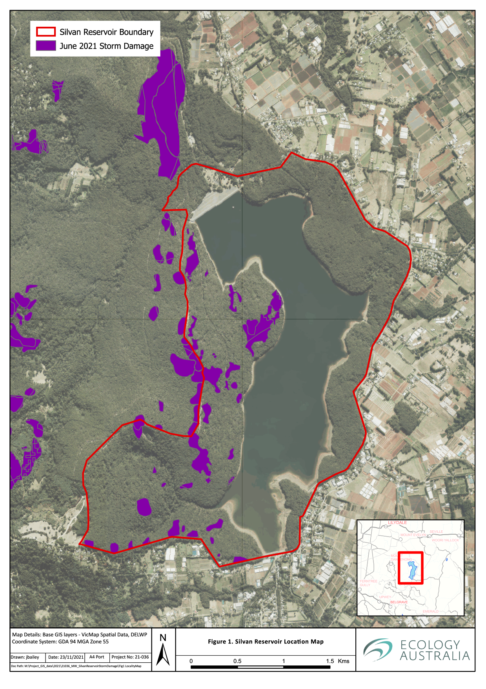
Figure 1 Site location of the Silvan Reservoir.

Summary of proposed remediation works
Below is a short summary of the proposed remediation works, with a focus on providing context to the potential sources of environmental impact and corresponding mitigation actions that are required.
In the areas where there is a significant volume of fallen trees from the storm, mechanical removal, or realignment of habitat logs to be retained on site, will be conducted if the following applies:
within one of the designated fuel-breaks
in areas where rapid suppression of lightning strike ignition would be significantly impaired
threats to threatened flora and fauna species can be mitigated
Significant planning by Melbourne Water and the log removal contractors has been conducted to identify implementation strategies, equipment, and timing to protect significant biodiversity values and the water quality of the Reservoir. Examples of these include:
- use tracked machinery in straight lines where possible to reduce soil and vegetation compaction
- use long reach machinery to minimise area of compaction
- realign and retain hollow logs within the site ensuring that the logs are generally aligned perpendicular to access tracks so that firefighting equipment can access the areas
- locate temporary tracks or log storage areas away from the root zones of unaffected trees and native vegetation
- exclude storm affected areas from treatment if they are small, or are away from tracks in close proximity, to sensitive ecological or water quality values such as the wet gullies in the south-west of the site
- conduct the works consistent with all relevant guidelines under the Code of Practice for Timber Production (DELWP 2021)

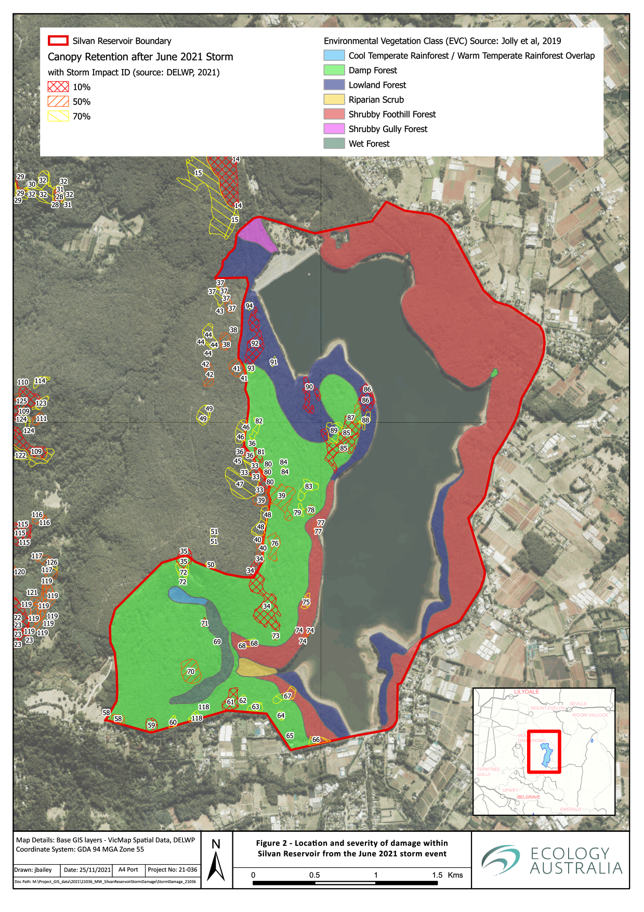
Figure 2 Location and severity of storm damage within the Silvan Reservoir from the June 2021 storm event.

Methods

Definitions

Likelihood of occurrence
Species that are listed as threatened under the EPBC Act (1999) or the FFG Act (1988) were assessed for likelihood of occurrence within the project area. Determining likelihood of occurrence is a subjective process which considers the following:
Documented habitats and ecological requirements for relevant species
Presence of suitable habitat within the site, based on a brief site assessment
Attributes of suitable habitat, including size, shape, and landscape context
Number, age, and distribution of previous records, considering the likely survey history in terms of intensity and frequency.
A general description of the likelihood classifications is provided in Table 1, below.
Table 1 Description of likelihood classifications.
Likelihood | Definition
Not Likely | Site is located outside the known geographic range for the taxon or does not contain necessary landscape features and/or habitats documented for that taxon.
Low | Site lies within, or on the edge of, the geographic range for the taxon, and supports major habitat elements, but is lacking in one or more critical features, or is located within a landscape that will most likely preclude occupancy or regular use. Historic records may be supported by more recent records within 5 km of the site or the relevant catchment (aquatic species).
Moderate | The location and geographic features of the site match that which is known for the taxon. Habitat shares numerous floristic, structural or physical similarities with documented habitats, but may be limited with regard to one or more known ecological requirements (e.g. size, landscape context or critical resources). Historic and contemporary records occur within 5 km of the site, within the relevant catchment (aquatic species) and/or the broader region.
High | Location of the site lies within the known range and distribution for the taxon. Habitats present within the site match that documented for the taxon regarding floristics and/or structure and satisfy the known ecological requirements. Multiple historic and recent records within the surrounding landscape indicate occurrence or regular use of the area.
Known | Taxon recorded within the site during the current assessment or other recent assessment.

Likelihood of significant impact
Once the likelihood of occurrence for threatened species at the subject site is determined, an assessment of the likelihood and scale of impact of the proposed development was conducted. Those species, or ecological communities, that had been determined as having a moderate or high likelihood of occurrence were then given more detailed consideration of potential impacts to them.
Each species was reviewed for information on its known ecology. Information that is useful in understanding the impacts at an individual or species level includes, but is not limited to:
- Important habitat elements
- Annual or perennial (flora)
- Timing of growth stages (flora)
- Roosting or breeding habitat and timing (fauna)
- Day and night-time activity (fauna)
- Ability to move away from disturbance (fauna)
The species or communities that were listed as Matters of National Environmental Significance (MNES) under the Environment Protection and Biodiversity Conservation Act 1999 (EPBC Act) are assessed using the Significant Impact Guidelines 1.1 – Matters of National Environmental Significance (DEWHA 2013).

Database review
A database review was conducted to compile information from the following sources:
- Flora and fauna records within 5 km of the study site held in DELWP’s Victorian Biodiversity Atlas (VBA) online database (DELWP 2021a)
- Records of ecological communities and flora and fauna species listed under the EPBC Act (1999) within a 5 km radius of the site using the EPBC Protected Matters Search Tool (DAWE 2021)
- Silvan Reservoir Biodiversity Conservation and Site Management Plan 2019 (Jolly et al 2019)
- Ecological Vegetation Class (EVC) mapping/modelling of the area (both extant and pre-1750) from DELWP’s NatureKit interactive map (DELWP 2021b)
- DELWP’s native vegetation information management tool (NVIM) to determine the assessment pathway of the proposed native vegetation removal and to generate the Native Vegetation Removal (NVR) report (DELWP 2021c)
- Relevant GIS data and aerial photography
- The Victorian Planning Schemes online (DTPLI 2021)
- Relevant legislation, government policies and strategies.
Flora taxonomy presented in the following sections follow the VBA (DELWP 2021b).

Site inspection
The site was visited on multiple occasions by professionals across botanical, zoological and aquatic specialties. Botanical assessments were completed over three days between the 25th and 27th of October 2021. The Zoology habitat inspections were conducted over two days (27th Oct and 11th Nov 2021). The Aquatic ecology assessments were conducted within the Wet Gully lines in the south-west corner of the site on the 10th November 2021.
As there had been numerous vegetation surveys completed at Silvan Reservoir in the previous decade (Jolly et al 2019) the botanical inspections by Ecology Australia were focused on assessing the likelihood of occurrence of threatened species within the storm damaged areas. The areas that had greater than 50% canopy cover remaining were prioritised for assessment as these sites are being investigated for critical fuel reduction treatments (logs and finer materials) from the storm damage.
Due to the condition of the storm damaged areas that were assessed as extremely high-risk areas to work within due to the unstable nature of remaining trees, large hanging branches and lack of clear and safe walking paths due to the volume and arrangement of large logs. All assessments by Ecology Australia were therefore restricted to the edges of the damaged areas.
Prior to site visits, a review of significant fauna species likely, or known, to occur within the site and adjacent surrounds, was undertaken to help determine what to focus upon. The subsequent zoological inspections of affected areas were focused within mostly intact habitat within the periphery of the areas with less than 50 % canopy retention. From these more intact areas, inspection of affected areas was done from safe locations, through use of binoculars. Surrounding areas, particularly areas situated between affected areas and existing access tracks which may be impacted by treatment activity, were closely inspected on foot by two zoologists. While traversing the site, an effort to identify any signs of fauna presence and/or activity was undertaken. Where signs, such as nests, possum dreys, tree hollows showing signs of recent activity, scratches / chew marks on tree bark, white-wash from roosting/nesting birds, burrows/diggings, scats, tracks and other incidental traces (fur, feathers, skeletal remains) were detected, these were recorded with a GPS, and photographed. Whilst moving throughout the broader site by vehicle (driven at a slow pace), attempts to determine the presence of significant shorebird and waterbird species, and any large raptors, and/or activity (particularly large raptor nesting activity) was undertaken.
Whilst on site, all incidental vertebrate fauna species were noted, with any significant species and/or observations also being recorded with a GPS and photographed where feasible.
The aquatic fauna site visit included visual habitat assessment and a rapid survey for fish, crayfish and macroinvertebrates in the headwater stream of Stoneyford Creek (south-west corner of Silvan Reservoir). Backpack electrofishing was undertaken 100 m upstream and downstream of the Rd 1 crossing of the stream using a Smith Root LR20B backpack electrofisher, with two shots of 150 seconds of ‘power on’ used in habitat of suitable depth to detect fish and crayfish. A cumulative 10 m rapid bioassessment ‘sweep’ sample (EPA 2003) was also collected downstream of the Rd 1 crossing. The sample was live-sorted for 30 minutes to collect amphipods and other taxa of potential interest (e.g. Ephemeroptera, Plecoptera, Trichoptera and Epiprocta). Collected specimens were retained in labelled jars and preserved in ethanol for subsequent microscope aided identification using taxonomic keys. A cursory identification to genus level was undertaken using Bradbury and Williams (1999).

Limitations
The seasonality of some plant species was a limitation to the field survey. The survey was undertaken in spring, which is an optimal time to survey for most flora in the local forested environments. However, several annual and geophytic species were likely absent or dormant following the completion of their annual lifecycle.
All assessments by Ecology Australia were restricted to the edges of the storm damaged areas due to the unstable nature of remaining trees, large hanging branches, and the large volume and large logs laying across each other.
However, the areas that were assessed were representative enough of the habitat types and quality, to infer the likely presence of and assess potential impacts to significant flora and fauna species.
This assessment did not involve targeted fauna surveys. Known records of threatened or significant species were used to assess likelihood of occurrence and potential impact. The database records for the site, along with expert assessment of habitat suitability provides a reliable basis for assessing of the likely impacts on these species.
As only two rapid site assessments for terrestrial fauna and their (potential) habitat were undertaken, it is likely that some species that are present were not detected at this time. Weather conditions required that the second site visit be cut short, so a complete assessment of all storm-damaged patches was not completed. However, the areas that were assessed were representative enough of the habitat types and quality, to infer the likely presence of and assess potential impacts to significant fauna species.
Only a rapid aquatic fauna survey was undertaken, covering a limited section (around 200 m) of one waterway, including a 50 m search for surface water on the southern arm, upstream of the confluence with the northern arm. An attempt to survey the lowest reaches of the waterway (immediately upstream of the current reservoir water level) was abandoned due to safety concerns associated with deep silt. The survey undertaken was considered sufficient to document the general aquatic fauna values, although some additional species (including fish) that inhabit the reservoir are likely occasionally use the lower reaches of the waterway. Burrowing crayfish (Engaeus spp.) burrows were also observed to occur in the immediate vicinity of the waterway. This genus would require a targeted survey approach (e.g. Norrocky traps) since many of the species in this genus are subterranean and do not inhabit waterways.

Results

Flora assessment
A total of 125 vascular flora taxa were recorded during the field survey (Appendix 1). Of these, 107 are indigenous species and 18 are exotic.

Landscape context
The site is situated within the Highlands – Southern Fall Bioregion, where the underlying geologies of the area consist primarily of sedimentary and granitic rocks. Porous earths in the upper regions provide the foundation for a range of vegetation types, dominated by Shrubby Dry Forest and Damp Forest. Occupying the valleys are Wet Forest vegetation communities atop texture contrast soils.
The vegetation mapping completed as part of the Silvan Reservoir Biodiversity Conservation Site Management Plan (Jolly et al. 2019) included six Ecological Vegetation Classes (EVCs) on the western side of the reservoir. It is noted that this mapping was also adapted from mapping completed by the same authors in 2010, and this is shown in Figure 3.
In the current ecological assessment, there was no clear separation of EVCs between the Damp Forest, Lowland Forest, and Shrubby Foothill Forests. Most of the western side of the reservoir would have been Damp Forest as evidenced by the commonly scattered clusters of Rough Tree Fern (Cyathea australis) across the site. However, the current floristics of the ground-storey vegetation through most of the areas previously mapped as Damp Forest, is more aligned with the Lowland Forest or Shrubby Foothill Forest EVCs. The application of fuel reduction burns at the site has put the vegetation in the ‘juvenile’ or ‘adolescence’ growth stages for the corresponding ‘Moist Forest’ Ecological Vegetation Division (EVD), based on Cheal (2010). The species of plants that are common of this growth stage and are represented at the site include Hop Goodenia (Goodenia ovata), Forest Wire-grass (Tetrarrhena juncea), Austral Bracken (Pteridium esculentum) and several Flat-peas (Platylobium spp).
A brief description of each EVC encountered is provided below. This includes typical native, and priority weed species recorded within the site.

Damp Forest (Least Concern)
Most of the storm-damaged areas fell within the Damp Forest Ecological Vegetation Class, on the western slopes of the Silvan Reservoir. The vegetation quality varied greatly across the site, with the main changes seen in the density of the small and medium shrub layers.
Native species recorded within the Damp Forest EVC include Mountain Grey-gum (Eucalyptus cypellocarpa), Messmate Stringybark (Eucalyptus obliqua), Hazel Pomaderris (Pomaderris aspera), Hop Goodenia, Snowy Daisy-bush (Olearia lirata), Blanket Leaf (Bedfordia arborescens), Forest Wire-grass, Austral Bracken, Rough Tree-fern, Victorian Flat-pea (Platylobium reflexum), and Mountain Clematis (Clematis aristata). Exotic species include Common Blackberry (Rubus anglocandicans), English Holly (Ilex aquifolium), Sweet Vernal-grass (Anthoxanthum odoratum), Spear Thistle (Cirsium vulgare), Creeping Buttercup (Ranunculus repens) and Fleabane (Erigeron sp.).

Lowland Forest (Least Concern)
Lowland Forest storm-damaged areas were restricted to the north-western corner of Silvan Reservoir, adjacent to and overlapping the Damp Forest EVC. A high diversity of shrubs, grasses and herbs were present, although densities varied across the site.
Lowland Forest was found to support a high proportion of native species cover with a sparse cover of herbaceous exotic species. This EVC had an overstorey consisting of Messmate Stringybark, Brown Stringybark (Eucalyptus baxteri) and Narrow-leaf Peppermint (Eucalyptus radiata subsp. radiata). Understorey species include Prickly Currant-bush (Coprosma quadrifida), Yellow Rice-flower (Pimelea flava), Holly Lomatia (Lomatia ilicifolia), Small Grass-tree (Xanthorrhoea minor subsp. lutea), Forest Wire-grass, Golden Bush-pea (Pultenaea gunnii), Ivy-leaf Violet (Viola hederacea), Black-anther Flax-Lily (Dianella revoluta s.l.), Common Raspwort (Gonocarpus tetragynus) and Tall Sundew (Drosera auriculata). Exotic species include Common Blackberry and Atlantic Ivy (Hedera hibernica).

Shrubby Foothill Forest – (Least Concern)
Shrubby Foothill Forest storm-damaged areas occurred on the western banks of the Silvan Reservoir, fringing the Damp Forest EVC and the reservoir.
The overstorey present within the Shrubby Foothill Forest consisted of Messmate Stringybark, Brown Stringybark, and Narrow-leaf Peppermint. Understorey natives included Cherry Ballart (Exocarpos cupressiformis), Dusty Miller (Spyridium parvifolium), Hop Goodenia, Pink-bells (Tetratheca ciliata), Austral Bracken, Common Raspwort, Holly Lomatia and Ivy-leaf Violet. Exotic species included Common Blackberry and Atlantic Ivy.

Wet Forest – (Least Concern)
Wet Forest occurred on the fertile soils of a protected gully in the south-western corner of the Silvan Reservoir. No significant storm damage occurred within this EVC.
The Wet Forest EVC consisted of a tall eucalypt overstorey of Mountain Ash (Eucalyptus regnans). The understorey consisted of Hazel Pomaderris, Musk Daisy-bush (Olearia argophylla), Prickly Currant-bush, Rough Tree-fern, Austral Bracken, Elderberry Panax (Polyscias sambucifolia), Silver Wattle (Acacia dealbata) and Mountain Clematis. Exotic species included Common Blackberry, Pimpernel (Lysimachia arvensis) and Common Elder (Sambucus nigra).

Cool Temperate/Warm Temperate Rainforest – (Endangered & Rare respectively)
According to Jolly et al. (2019), there was a patch of Cool Temperate/Warm Temperate Rainforest adjacent to the Wet Forest EVC, in a protected gully in the headwaters of Stoneyford Creek. No significant storm damage occurred within this EVC.
The overstorey in the Cool Temperate/Warm Temperate Rainforest was dominated by Southern Sassafras (Atherosperma maschatum), Blackwood (Acacia melanoxylon) and Hazel Pomaderris. Understorey species included Muttonwood (Myrsine howittiana), Banyalla (Pittosporum bicolor), Prickly Currant-bush, Mother Shield-fern (Polystichum proliferum), Gristle Fern (Blechnum cartilagineum), Scrambling Coral-fern (Gleichenia microphylla), Mountain Clematis and Ivy-leaf Violet. Exotic species included Common Blackberry and English Holly.

Riparian Scrub (Vulnerable)
There is a small area of Riparian Scrub that is located along the unnamed headwater stream of Stoneyford Creek where it meets the reservoir. No significant storm damage occurred within this EVC.
This EVC had an overstorey of Scented Paperbark (Melaleuca squarossa) and Woolly Tea-tree (Leptospermum lanigerum). A dominant species of the understorey was Scrambling Coral-fern, along with sedges such as Red-fruited Saw-sedge (Gahnia sieberiana) and Tall Sword-sedge (Lepidosperma elatius).

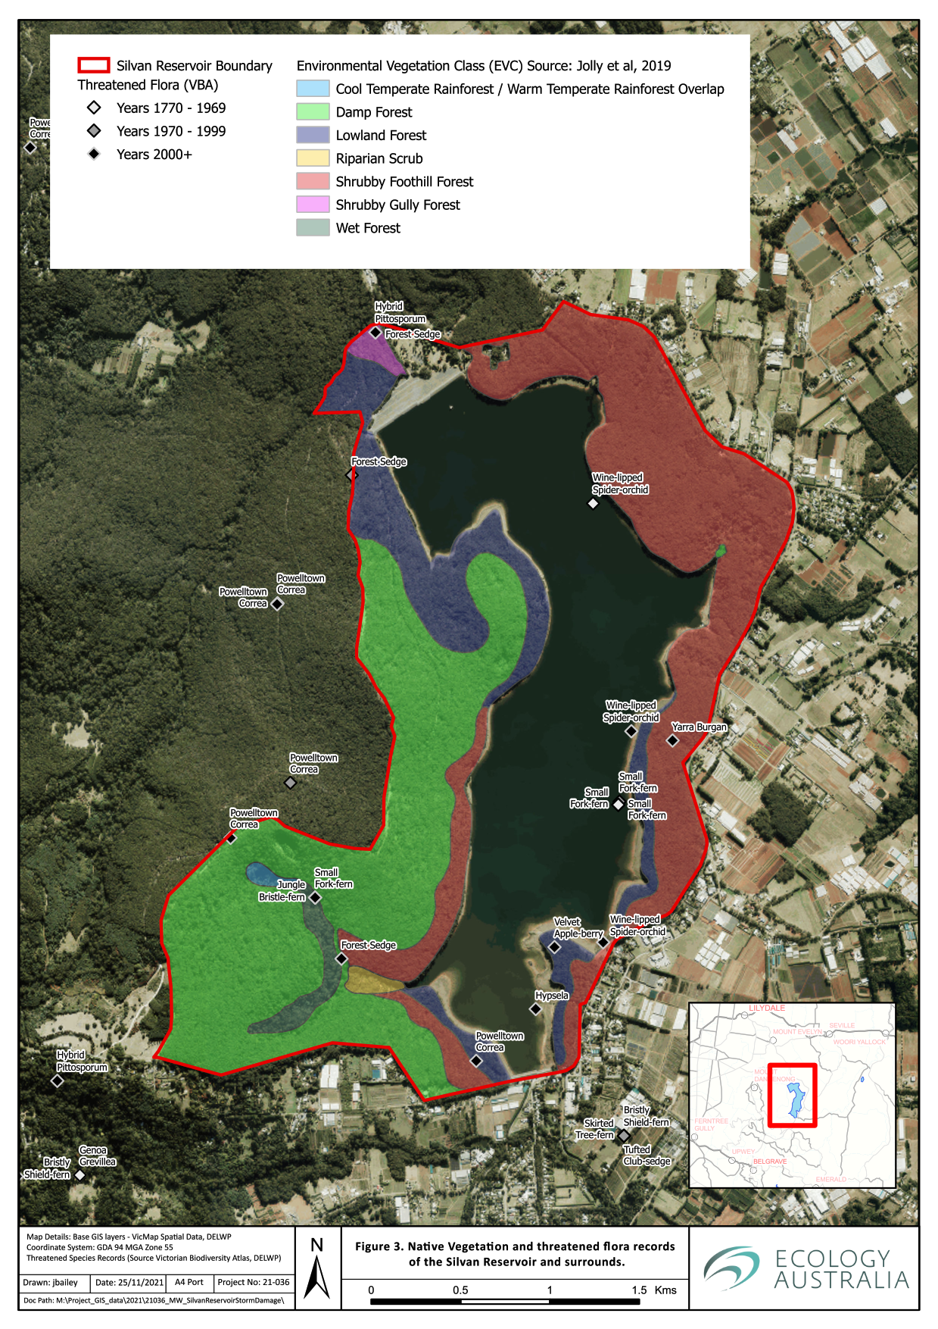
Figure 3 Native Vegetation and threatened flora records of the Silvan Reservoir and surrounds.

Fauna habitat
The proposed works area contains and borders a variety of habitats that provide feeding and breeding grounds for a range of fauna species.

Deep water and shallow margins
The reservoir provides large expanses of open water habitat for fauna species. The native fauna species that make regular use of this open water habitat at Silvan include White-bellied Sea-Eagle (Haliaeetus leucogaster), Musk Duck (Biziura lobata) and other duck species such as Hardhead (Aythya australis), Pacific Black Duck (Anas superciliosa), Grey Teal (Anas gracilis) and Australian Wood Duck (Chenonetta jubata).
The reservoir does have shallow margins that would provide some limited habitat to bird species requiring these areas. However, there is very little fringing or aquatic vegetation for many fauna species to use for shelter, foraging or breeding.
There is little information available on the fishes that occur in Silvan Reservoir, with a single 1989 VBA record of two species: the introduced Brown Trout (Salmo trutta) and the native River Blackfish (Gadopsis marmoratus). One further 1993 record of River Blackfish exists in the Atlas of Living Australia online database, while there are anecdotal reports on recreational fishing websites (https://fishbrain.com) of other introduced species caught recently (2021) including Redfin (Perca fluviatilis) and Atlantic Salmon (Salmo salar).

Damp / Lowland Forest- high density shrub and groundcover
There were extensive diggings, largely attributable to Short-beaked Echidna (Tachyglossus aculeatus) foraging activity, or Bare-nosed Wombat (Vombatus ursinus) burrows, in addition to several Burrowing crayfish (Engaeus spp.) burrows and associated ‘chimneys’ being observed. In the central western portion of the site where there was storm damage with associated increased cover of fallen logs, diggings were noticeably absent, and/or visibly older.

Roosting Habitat
Peregrine Falcons (Falco peregrinus) were actively defending an area surrounding a large old tree just outside of an extensive area of storm damage, near the central western shoreline of the reservoir. Three individuals were heard calling, with two adults concurrently observed (a male and a female). The presence of extensive whitewash beneath a large hollow/depression in the upper part of the tree indicates this is likely an active nesting site.
At least one White-bellied Sea-Eagle was observed within the site during the terrestrial fauna survey (two were observed during the aquatic fauna survey), appearing to largely be associated with the eastern shoreline and adjacent forested areas, of the reservoir. On one occasion, a single bird was flushed from roosting on a branch above the shoreline access track to the north-east of the site. A search while driving along the shoreline track did not detect any nests, however, so it was not possible to confirm if the species is breeding within the immediate area or just roosting and/or foraging.
A pair of Wedge-tailed Eagles (Aquila audax) were seen on several occasions, quartering the saddle between larger patches of storm damage, in the north-western area of the site.
With no confirmed nests for either White-bellied or Wedge-tailed Eagles being found, and both species having large home ranges, it is possible that these species could have nests outside of the Silvan Reservoir site.
Regarding large forest owl species, several large old trees with potentially suitable hollows were observed. One such tree had whitewash, but no visible bird activity; a quick search for discarded prey remains and pellets within its proximity did not detect any. However, birds of prey often consume prey away from roost/nesting sites, so it is still possible that this tree supports such species, or other hollow-dependent, large bird species.

Stoneyford Creek headwaters
The unnamed headwater stream of Stoneyford Creek in the south-western corner of Silvan Reservoir was flowing gently at the time of survey and provided shallow (0–5 cm) habitat over a silt dominated substrate. The channel was poorly defined and often braided into two or more shallow channels. The southern arm of the creek dissipated above the confluence with the northern arm. The northern arm was essentially contiguous with the section downstream of the confluence. Except for a scour pool immediately beneath the culvert at the Rd 2 crossing, the depth of the creek was insufficient to provide suitable habitat for fish. The creek was confirmed to support Central Highlands Spiny Crayfish (Euastacus woiwuru), Freshwater Shrimp ([Paratya australiensis] in the scour pool only) and a range of macroinvertebrate taxa including an Amphipod species (Austrogammarus sp.) that is yet to be identified to species level.

Threatened species and communities

Threatened ecological communities
No EPBC Act (1999) listed ecological communities are modelled as potentially occurring within 5 km of the site (DAWE 2020).
There is a FFG Act (1988) listed Cool Temperate Rainforest Community present in the unnamed headwaters of Stoneyford Creek within Silvan Reservoir.

Threatened Fauna Species
A total of 54 rare or threatened fauna species have been recorded or were predicted to occur within 5 km of the site (DAWE 2020; DELWP 2020a). This included:
- 25 species listed threatened under the EPBC Act (1999)
- 54 species listed as threatened under the FFG Act (1988)
Threatened fauna records within proximity of Silvan Reservoir in the Victorian Biodiversity Atlas are shown in map form in Figure 4. In usual circumstances, a catchment-based aquatic fauna search would have been undertaken. However, as the site is effectively cut off from surrounding catchments, a 5 km search was deemed sufficient for this data review.
In addition to those fauna species classified as threatened, an additional six species listed as migratory, or marine overfly species under the EPBC Act (1999) were predicted to occur within 5 km of the site. The full list of potential threatened fauna species is shown in Appendix 3.
A likelihood of occurrence rating has been assigned to each species based on the criteria outlined in Table 2. These include:
- Five nationally significant species, that are present or with moderate or high likelihood of occurrence are listed as both Migratory and Marine Species; White-throated Needletail (Hirundapus caudacutus), Fork-tailed Swift (Apus pacificus), Rainbow Bee-eater (Merops ornatus) and Satin Flycatcher (Myiagra cyanoleuca), with the White-bellied Sea-Eagle being present.
- There are an additional 15 species of fauna that are only listed under the Marine lists of the EPBC Act, including species such as Whistling Kite (Haliastur sphenurus), Welcome Swallow (Hirundo neoxena), Blue-winged Parrot (Neophema chrysostoma) and Sacred Kingfisher (Todiramphus sanctus), the latter three species were all seen on site.
- There are 14 threatened species that are only of state significance under the FFG Act that are present or have a moderate or high likelihood of occurrence at the subject site, including Sooty Owl (Tyto tenebricosa), Dandenong Freshwater Amphipod (Austrogammurus australis), Tubercle Burrowing Crayfish (Engaeus tuberculatus), Dandenong Burrowing Crayfish (Engaeus urostrictus), Powerful Owl (Ninox strenua) and Lace Monitor (Varanus varius).

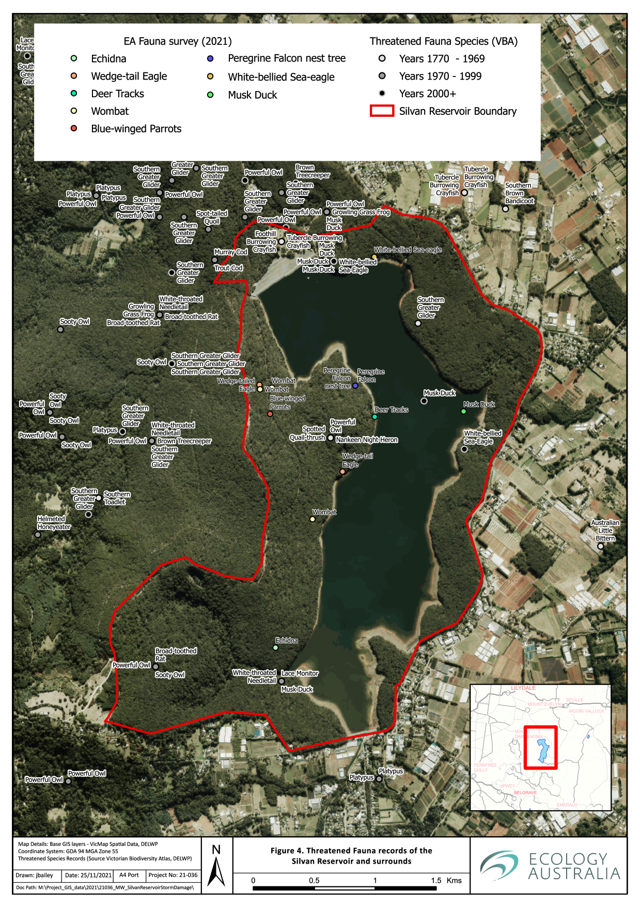
Figure 4 Threatened or significant fauna records of the Silvan Reservoir and surrounds

Table 2. All threatened fauna species (FFG and EPBC Acts) that are present or have a moderate or high likelihood of occurrence at Silvan Reservoir.
Scientific Name | Common Name | EPBC | Mi | Ma | FFG Act.  Category of Threat | FFG Act. Extinction Risk | Source | Number of Records | Last Record | Likelihood of occurrence
Hirundapus caudacutus | White-throated Needletail | VU | Mi | Ma | Vulnerable | Victoria | VBA, PMST | 38 | 2016 | High
Mastacomys fuscus mordicus | Broad-toothed Rat | VU |  |  | Vulnerable | Victoria | VBA, PMST | 20 | 1989 | Moderate
Petauroides volans | Southern Greater Glider | VU |  |  | Vulnerable | Victoria | VBA, PMST | 31 | 2021 | High
Apus pacificus | Fork-tailed Swift |  | Mi | Ma |  |  | PMST | NA | NA | Moderate
Haliaeetus leucogaster | White-bellied Sea-Eagle |  | Mi | Ma | Endangered | Victoria | VBA, PMST | 3 | 2021 | Known
Merops ornatus | Rainbow Bee-eater |  | Mi | Ma |  |  | PMST | NA | NA | Moderate
Myiagra cyanoleuca | Satin Flycatcher |  | Mi | Ma |  |  | PMST | NA | NA | Moderate
Accipiter fasciatus | Brown Goshawk |  |  | Ma |  |  | VBA | 88 | 2020 | High
Biziura lobata | Musk Duck |  |  | Ma | Vulnerable | Victoria | VBA | 7 | 2021 | Known
Cacomantis flabelliformis | Fan-tailed Cuckoo |  |  | Ma |  |  | VBA | 130 | 2021 | Known
Coracina novaehollandiae | Black-faced Cuckoo-shrike |  |  | Ma |  |  | VBA | 78 | 2021 | Known
Corvus mellori | Little Raven |  |  | Ma |  |  | VBA | 208 | 2021 | Known
Falco cenchroides | Nankeen Kestrel |  |  | Ma |  |  | VBA | 6 | 2017 | Moderate
Grallina cyanoleuca | Magpie-lark |  |  | Ma |  |  | VBA | 236 | 2021 | Known
Haliastur sphenurus | Whistling Kite |  |  | Ma |  |  | VBA | 5 | 2017 | Moderate
Hirundo neoxena | Welcome Swallow |  |  | Ma |  |  | VBA | 173 | 2021 | Known
Neophema chrysostoma | Blue-winged Parrot |  |  | Ma |  |  | VBA | 11 | 2021 | Known
Petroica phoenicea | Flame Robin |  |  | Ma |  |  | VBA | 17 | 2007 | High
Petroica rodinogaster | Pink Robin |  |  | Ma |  |  | VBA | 10 | 2018 | High
Threskiornis spinicollis | Straw-necked Ibis |  |  | Ma |  |  | VBA | 22 | 2020 | Moderate
Todiramphus sanctus | Sacred Kingfisher |  |  | Ma |  |  | VBA | 30 | 2021 | Known
Zosterops lateralis | Silvereye |  |  | Ma |  |  | VBA | 236 | 2021 | Known
Accipiter novaehollandiae | Grey Goshawk |  |  |  | Endangered | Victoria | VBA | 11 | 2019 | High
Austrogammarus australis | Dandenong Freshwater Amphipod |  |  |  | Critically Endangered | Victoria | VBA | 47 | 2011 | High
Austrogammarus haasei | Sherbrooke Amphipod |  |  |  | Endangered | Victoria | VBA | 2 | 1999 | Moderate
Aythya australis | Hardhead |  |  |  | Vulnerable | Victoria | VBA | 1 | 1987 | Moderate
Engaeus tuberculatus | Tubercle Burrowing Crayfish |  |  |  | Endangered | Australia | VBA | 16 | 2019 | High
Engaeus urostrictus | Dandenong Burrowing Crayfish |  |  |  | Critically Endangered | Australia | VBA | 15 | 2019 | High
Engaeus victoriensis | Foothill Burrowing Crayfish |  |  |  | Endangered | Australia | VBA | 6 | 2011 | High
Hieraaetus morphnoides | Little Eagle |  |  |  | Vulnerable | Victoria | VBA | 16 | 2018 | High
Lophoictinia isura | Square-tailed Kite |  |  |  | Vulnerable | Victoria | VBA | 1 | 2018 | Moderate
Ninox connivens | Barking Owl |  |  |  | Critically Endangered | Victoria | VBA | 3 | 2004 | Moderate
Ninox strenua | Powerful Owl |  |  |  | Vulnerable | Victoria | VBA | 140 | 2019 | High
Spatula rhynchotis | Australasian Shoveler |  |  |  | Vulnerable | Victoria | VBA | 1 | 2018 | Moderate
Tyto tenebricosa | Sooty Owl |  |  |  | Endangered | Victoria | VBA | 88 | 2019 | High
Varanus varius | Lace Monitor |  |  |  | Endangered | Victoria | VBA | 14 | 2019 | Moderate

Table 3 Nationally significant threatened fauna species with moderate or higher likelihood of occurrence.
Scientific Name | Common Name | EPBC | Mi | Ma | FFG Act.  Category of Threat | FFG Act. Extinction Risk | Source | Number of Records | Last Record | Likelihood of occurrence
Hirundapus caudacutus | White-throated Needletail | VU | Mi | Ma | Vulnerable | Victoria | VBA, PMST | 38 | 2016 | High
Mastacomys fuscus mordicus | Broad-toothed Rat | VU |  |  | Vulnerable | Victoria | VBA, PMST | 20 | 1989 | Moderate
Petauroides volans | Southern Greater Glider | VU |  |  | Vulnerable | Victoria | VBA, PMST | 31 | 2021 | High

Table 4 Nationally Significant Migratory or Marine Species with a moderate or high likelihood of occurrence.
Scientific Name | Common Name | EPBC | Mi | Ma | FFG Act. Category of Threat | FFG Act. Extinction Risk | Source | Number of Records | Last Record | Likelihood of occurrence
Hirundapus caudacutus | White-throated Needletail | VU | Mi | Ma | Vulnerable | Victoria | VBA, PMST | 38 | 2016 | High
Apus pacificus | Fork-tailed Swift |  | Mi | Ma |  |  | PMST | NA | NA | Moderate
Haliaeetus leucogaster | White-bellied Sea-Eagle |  | Mi | Ma | Endangered | Victoria | VBA, PMST | 3 | 2021 | Known
Merops ornatus | Rainbow Bee-eater |  | Mi | Ma |  |  | PMST | NA | NA | Moderate
Myiagra cyanoleuca | Satin Flycatcher |  | Mi | Ma |  |  | PMST | NA | NA | Moderate
Accipiter fasciatus | Brown Goshawk |  |  | Ma |  |  | VBA | 88 | 2020 | High
Biziura lobata | Musk Duck |  |  | Ma | Vulnerable | Victoria | VBA | 7 | 2021 | Known
Cacomantis flabelliformis | Fan-tailed Cuckoo |  |  | Ma |  |  | VBA | 130 | 2021 | Known
Coracina novaehollandiae | Black-faced Cuckoo-shrike |  |  | Ma |  |  | VBA | 78 | 2021 | Known
Corvus mellori | Little Raven |  |  | Ma |  |  | VBA | 208 | 2021 | Known
Falco cenchroides | Nankeen Kestrel |  |  | Ma |  |  | VBA | 6 | 2017 | Moderate
Grallina cyanoleuca | Magpie-lark |  |  | Ma |  |  | VBA | 236 | 2021 | Known
Haliastur sphenurus | Whistling Kite |  |  | Ma |  |  | VBA | 5 | 2017 | Moderate
Hirundo neoxena | Welcome Swallow |  |  | Ma |  |  | VBA | 173 | 2021 | Known
Neophema chrysostoma | Blue-winged Parrot |  |  | Ma |  |  | VBA | 11 | 2021 | Known
Petroica phoenicea | Flame Robin |  |  | Ma |  |  | VBA | 17 | 2007 | High
Petroica rodinogaster | Pink Robin |  |  | Ma |  |  | VBA | 10 | 2018 | High
Threskiornis spinicollis | Straw-necked Ibis |  |  | Ma |  |  | VBA | 22 | 2020 | Moderate
Todiramphus sanctus | Sacred Kingfisher |  |  | Ma |  |  | VBA | 30 | 2021 | Known
Zosterops lateralis | Silvereye |  |  | Ma |  |  | VBA | 236 | 2021 | Known
Table 5 State significant species, with moderate or higher likelihood of occurrence at Silvan Reservoir. These are the species that have not already been included in the Nationally Significant species lists presented in Table 3 and Table 4.
Scientific Name | Common Name | EPBC | Mi | Ma | FFG Act. Category of Threat | FFG Act. Extinction Risk | Source | Number of Records | Last Record | Likelihood of occurrence
Lophoictinia isura | Square-tailed Kite |  |  |  | Vulnerable | Victoria | VBA | 1 | 2018 | Moderate
Ninox strenua | Powerful Owl |  |  |  | Vulnerable | Victoria | VBA | 140 | 2019 | High
Aythya australis | Hardhead |  |  |  | Vulnerable | Victoria | VBA | 1 | 1987 | Moderate
Hieraaetus morphnoides | Little Eagle |  |  |  | Vulnerable | Victoria | VBA | 16 | 2018 | High
Spatula rhynchotis | Australasian Shoveler |  |  |  | Vulnerable | Victoria | VBA | 1 | 2018 | Moderate
Accipiter novaehollandiae | Grey Goshawk |  |  |  | Endangered | Victoria | VBA | 11 | 2019 | High
Austrogammarus haasei | Sherbrooke Amphipod |  |  |  | Endangered | Victoria | VBA | 2 | 1999 | Moderate
Tyto tenebricosa | Sooty Owl |  |  |  | Endangered | Victoria | VBA | 88 | 2019 | High
Engaeus tuberculatus | Tubercle Burrowing Crayfish |  |  |  | Endangered | Australia | VBA | 16 | 2019 | High
Engaeus victoriensis | Foothill Burrowing Crayfish |  |  |  | Endangered | Australia | VBA | 6 | 2011 | High
Varanus varius | Lace Monitor |  |  |  | Endangered | Victoria | VBA | 14 | 2019 | Moderate
Austrogammarus australis | Dandenong Freshwater Amphipod |  |  |  | Critically Endangered | Victoria | VBA | 47 | 2021 | High
Engaeus urostrictus | Dandenong Burrowing Crayfish |  |  |  | Critically Endangered | Australia | VBA | 15 | 2019 | High
Ninox connivens | Barking Owl |  |  |  | Critically Endangered | Victoria | VBA | 3 | 2004 | Moderate

Threatened Flora Species
A total of 40 threatened flora species were predicted to occur within 5 km of the site (DAWE 2020, DELWP 2020a). This included:
- eight species listed threatened under the EPBC Act (1999)
- 39 species listed as threatened under the FFG Act (1988)
Of these there are 17 species that have a moderate (six species) or high (11 species) likelihood of occurrence at Silvan Reservoir. None of these flora species are listed under the EPBC Act (Table 4).
Of the 11 species with a high likelihood of occurrence, two of them a are listed under the FFG Act as Critically Endangered: Wine-lipped Spider-orchid and Slender Tree-fern (Cyathea cunninghamii).
Threatened flora records within proximity of Silvan Reservoir in the Victorian Biodiversity Atlas are shown in map form in Figure 5, on following page. The full list of threatened flora species with a moderate or high likelihood of occurrence at Silvan Reservoir is shown inTable 6.
There are several species of ferns that are likely to be confined to the wet gully area in the south-west of Silvan Reservoir including: Jungle Bristle-fern (Abrodictyum caudatum), Bristly Shield-fern (Lastreopsis hispida), Small Fork-fern (Tmesipteris parva) and Netted Brake (Pteris epaleata).
Dandenong Wattle (Acacia stictophylla) and Velvet Apple berry (Billardiera scandens s.s.) were not detected during the surveys undertaken for this study, however, are likely to be present in low numbers.
Powelltown Correa has several known locations within the site and several more plants were located as part of the surveys undertaken for this study (Figure 5).
There are three species of Flat-pea (Platylobium spp.) that have been found within proximity of Silvan Reservoir. These species were once part of Platylobium formosum until taxonomic revision split these into several species. Famine Flat-pea (Platylobium infecundum) has been recorded within 5 km of Silvan at Mt Evelyn. Mountain Flat-pea (Platylobium montanum) was recorded in Silvan in 2019 by Jolly et al. (2019). During the field surveys for this report, Victorian Flat-pea (Platylobium reflexum) was recorded. However, it is likely that all three Flat -pea species occur at the site, and could easily be overlooked during a rapid survey, as the taxonomic differences are very small. The Flat peas were quite prolific in many areas that have recently undergone fuel reduction burns. However, Famine Flat Pea is mostly infecund, meaning that it rarely produces viable seed, and mainly spreads vegetatively.

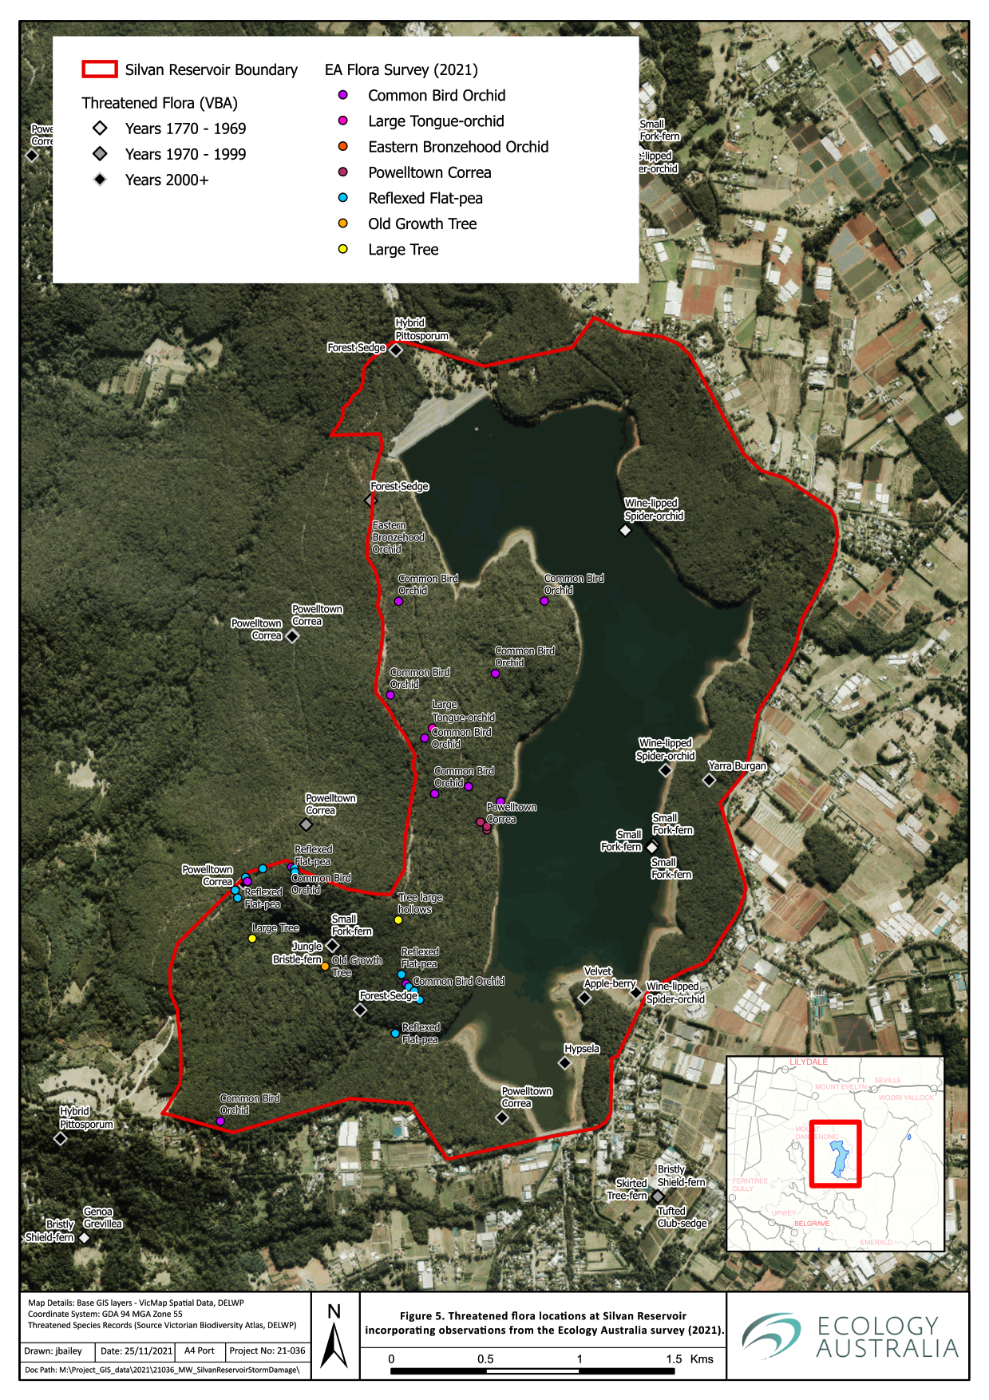
Figure 5 Threatened flora locations at Silvan Reservoir incorporating observations from the Ecology Australia survey in 2021.

Table 6 Threatened Flora of Moderate or high likelihood of occurrence at Silvan Reservoir.
Scientific Name | Common Name | EPBC | FFG Category of Threat | FFG Extinction Risk | Source | Number of Records | Last Record | Likelihood of occurrence
Abrodictyum caudatum | Jungle Bristle-fern |  | Endangered | Victoria | VBA | 2 | 3/03/2015 | High
Acacia stictophylla | Dandenong Wattle |  | Endangered | Australia | VBA | 19 | 13/11/2019 | High
Caladenia oenochila | Wine-lipped Spider-orchid |  | Critically Endangered | Victoria | VBA | 13 | 25/09/2012 | High
Carex alsophila | Forest Sedge |  | Endangered | Australia | VBA | 4 | 5/01/2010 | High
Chiloglottis jeanesii | Mountain Bird-orchid |  | Vulnerable | Australia | VBA | 7 | 23/11/2004 | High
Correa reflexa var. lobata | Powelltown Correa |  | Endangered | Australia | VBA | 11 | 14/02/2017 | High
Corybas aconitiflorus | Spurred Helmet-orchid |  | Endangered | Victoria | VBA | 3 | 12/05/2006 | High
Cyathea cunninghamii | Slender Tree-fern |  | Critically Endangered | Victoria | VBA | 11 | 1/07/2013 | High
Lastreopsis hispida | Bristly Shield-fern |  | Endangered | Victoria | VBA | 4 | 17/04/1994 | High
Platylobium reflexum | Victorian Flat-pea |  | Endangered | Australia | VBA | 1 | 1/10/1902 | Known (2021)
Tmesipteris parva | Small Fork-fern |  | Endangered | Victoria | VBA | 5 | 3/03/2015 | High
Beyeria lanceolata | Pinkwood |  | Endangered | Victoria | VBA | 8 | 9/11/2017 | Moderate
Billardiera scandens s.s. | Velvet Apple-berry |  | Endangered | Victoria | VBA | 5 | 24/11/2009 | Moderate
Caladenia flavovirens | Christmas Spider-orchid |  | Critically Endangered | Victoria | VBA | 5 | 7/12/1980 | Moderate
Platylobium infecundum | Famine Flat-pea |  | Critically Endangered | Australia | VBA | 1 | 20/08/2014 | Moderate
Prasophyllum lindleyanum | Green Leek-orchid |  | Endangered | Victoria | VBA | 1 | 16/10/2007 | Moderate
Pteris epaleata | Netted Brake |  | Endangered | Victoria | VBA | 5 | 21/03/1980 | Moderate

Assessment of significant impacts to Matters of National Environmental Significance

Summary of the relevant Matters of National Environmental Significance

Threatened communities
No EPBC Act (1999) listed communities were recorded within the site.

Threatened and migratory species
Two EPBC Act (1999) listed threatened species have a high or moderate likelihood of occurrence within the area anticipated to be impacted by the planned works, including one species which is also listed under migratory and marine provisions of the Act. There are also an additional three species of fauna that are listed under both the migratory and marine provisions of the EPBC Act. Further to this, an additional 15 species are listed under only the marine provisions of the EPBC Act.
The assessment of the likelihood of significant impact on these MNES from the proposed storm damage remediation works is summarised in Table 7.
There has been significant planning to date with broad mitigation actions to protect and mitigate impacts on these MNES including:
- Protecting standing trees within storm damaged areas where safe to do so
- Use of existing tracks to access storm damaged areas
- No log removal near the wet gully areas with significant biodiversity values
- Not completing the log removal works in wet weather to avoid damage to soil strata and associated habitat for semi-aquatic species (e.g. burrowing crayfish)
- Retention of existing dead trees (where safe) in the treatment areas
- Maximise the retention of hollow logs within the treatment areas
- Use of long reach machinery to allow some treatment areas to not be driven upon
- Design of log removal access routes to minimise the amount of turning the large-tracked vehicles to minimise compaction of soil
- Ensure natural regeneration of treated and untreated areas occurs
With the development and implementation of project-specific plans, including adherence to relevant Codes of Practice (e.g. The Code of Practice for Timber Production [DELWP, amended 2021]), it is unlikely that there will be significant impacts to MNES under the EPBC Act.
Table 7 Likelihood of significant impact from the proposed storm damage remediation works on Matters of National Environmental Significance under the EPBC Act.
Scientific Name | Common Name | EPBC | Mi | Ma | Likelihood of occurrence | Significant Impact Likelihood | Summary of likelihood of significant impact
Hirundapus caudacutus | White-throated Needletail | VU | Mi | Ma | High | Not Likely | Highly mobile species. No significant impact on their habitat.
Mastacomys fuscus mordicus | Broad-toothed Rat | VU |  |  | Moderate | Low | Protection of potential habitat in the wet gullies
Petauroides volans | Southern Greater Glider | VU |  |  | High | Low | Protect standing large trees. Retain standing dead trees in treatment areas.
Haliaeetus leucogaster | White-bellied Sea-Eagle |  | Mi | Ma | Known | Low | Highly mobile species. Protection of standing large trees. No confirmed nest locations within proximity to the treatment areas.
Apus pacificus | Fork-tailed Swift |  | Mi | Ma | Moderate | Not Likely | Highly mobile species. No impact on their habitat.
Myiagra cyanoleuca | Satin Flycatcher |  | Mi | Ma | Moderate | Low | Highly mobile species. Protection of standing live and dead trees including those with nesting hollows.
Biziura lobata | Musk Duck |  |  | Ma | Known | Not likely | Highly mobile species. Protection of their aquatic habitat.
Accipiter fasciatus | Brown Goshawk |  |  | Ma | High | Low | Highly mobile species. No impact on their habitat.
Cacomantis flabelliformis | Fan-tailed Cuckoo |  |  | Ma | Known | Low | Highly mobile species. No impact on their habitat.
Coracina novaehollandiae | Black-faced Cuckoo-shrike |  |  | Ma | Known | Low | Highly mobile species. No impact on their habitat.
Corvus mellori | Little Raven |  |  | Ma | Known | Low | Highly mobile species. No impact on their habitat.
Falco cenchroides | Nankeen Kestrel |  |  | Ma | Moderate | Low | Highly mobile species. No impact on their habitat.
Grallina cyanoleuca | Magpie-lark |  |  | Ma | Known | Low | Highly mobile species. No impact on their habitat.
Haliastur sphenurus | Whistling Kite |  |  | Ma | Moderate | Low | Highly mobile species. No impact on their habitat.
Hirundo neoxena | Welcome Swallow |  |  | Ma | Known | Not Likely | Highly mobile species. No impact on their habitat.
Neophema chrysostoma | Blue-winged Parrot |  |  | Ma | Known | Low | Highly mobile species. Protection of standing live and dead trees including those with nesting hollows.
Petroica phoenicea | Flame Robin |  |  | Ma | High | Low | Protection of shrub habitat areas that were not storm affected.
Petroica rodinogaster | Pink Robin |  |  | Ma | High | Low | Protection of shrub habitat areas that were not storm affected.
Threskiornis spinicollis | Straw-necked Ibis |  |  | Ma | Moderate | Low | Highly mobile species. No impact on their habitat. No roosting sites were observed at Silvan
Todiramphus sanctus | Sacred Kingfisher |  |  | Ma | Known | Low | Highly mobile species. Protection of standing live and dead trees including those with nesting hollows.
Zosterops lateralis | Silvereye |  |  | Ma | Known | Low | Highly mobile species. No impact on their habitat.

Three species of EPBC Act-listed threatened fauna; White-throated Needletail, Musk Duck, and White-bellied Sea-Eagle are deemed as not likely to be significantly impacted by the proposed remediation works, due to their habitats not overlapping with the proposed works areas.
No White-throated Needletail were observed on site, however, the species has a high likelihood of occurrence at any point in time while it is present in south-eastern Australia (during the austral spring/summer), and it is a species that rarely lands.
A single Musk Duck was observed within an embayment on the eastern side of the reservoir. Musk Duck are deep-water specialists, foraging widely within suitable waterbodies, and nesting in reeds in the water. There are very limited areas of fringing or emergent aquatic vegetation within the reservoir that would provide suitable breeding habitat for the species. In addition to this, the species is quite mobile.
White-bellied Sea-Eagles were observed on site during most of the site assessment visits undertaken. These observations were of individuals roosting on the ground, within canopy trees on the eastern shoreline of the reservoir or foraging above the reservoir and the forest to the east.
Storm damage remediation works are situated to the west of the reservoir will not have a significant impact on these three species (Table 7). A significant impact assessment using the Significant impact Guidelines (DAWE 2013) was undertaken in greater detail for two species with the potential to occur within the proposed works area: Broad-toothed Rat and Southern Greater Glider.

Broad-toothed Rat (Vulnerable – EPBC Act)

Species ecology, local habitat information and threats
The Broad-toothed Rat was last recorded in 1989, with several records within a 5 km radius of the site. Two of the three records from 1989, within, or in proximity, to the site were based on identification from predator scats (possibly from owl pellet scats), including one collected from the south-west portion of the site. Therefore, the accuracy of the locations of these two Broad-toothed Rat records are considerably limited by the distance the predator has moved between the point of capture or consumption and subsequent point of expelling the scat or pellet. The third record was from individuals observed within 1 km to the west of the north-west portion of the site (see Figure 6).
The Broad-toothed Rat is a small mammal with a head and body length of 142–175 mm long and a tail length of 100–130 mm and weighs 97–145 g (Happold 1995). This species is found within damp habitats, ranging from subalpine heathlands to coastal grasslands (Menkhorst 1995). Specifically, within areas of 300–1000 m altitude, as is the case for the Silvan Reservoir, the species occupies wet forest where there is a dense, wet understorey present – generally with a dense ground layer of grasses, sedges, and herbs (Menkhorst 1995). This habitat could also be comprised of patches of sedgeland or on creekline flats within forest canopy openings (Menkhorst 1995). The species is known to occupy areas of Blackberry (Rubus fruticosus spp. agg.), Forest Wire-grass and Radiata Pine (Pinus radiata) (Menkhorst 1995).
The species is herbivorous, and largely forages upon the stems and leaves of grasses and sedges, and to a lesser extent, seeds and leaves of shrubs, eating 50–70 % of its body weight each day (Happold 1995, Menkhorst 1995); of which it leaves piles of ‘clippings’, providing an indication of the species’ presence and activity in a given area. As such, this relatively narrow diet is likely to largely restrict where they would occur within the site. The site assessment indicates that the area most likely to support the species would be within the wetter gullies to the south-west of the site (Figure 6).
Home ranges of the species varies across seasons, ranging from 1600 m² in the breeding season (females) and 2700 m² (males), and decreasing to approximately 1000 m² (both males and females) after the breeding season (Happold 1995). These home ranges have been found to consist of a smaller day-to-day core area of only about 350 m² (a distance less than 20 m) at Mt Buller Alpine Resort, and the species is known to undertake longer movements, periodically, of 500–1000 m (Whisson et al. 2015).
This species is largely solitary in nature, but during the breeding season, females may have overlapping home ranges and generally have two litters a year, with juveniles not breeding until the following summer; in winter the species often nests communally (Happold 1995, Menkhorst 1995). Predation by foxes and cats and habitat loss or destruction by agriculture, increased fire frequency or intensity, and introduced herbivores, such as deer has likely had an impact on the species’ overall distribution and connectivity between populations, which are highly disjunct.

Significant Impact Criteria Assessment
The proposed log removal and remediation of the storm damaged areas is not likely to have a significant impact on Broad-toothed Rat. The findings of the significant impact assessment on Broad-toothed Rat are shown in Table 8, below.
Table 8 EPBC Act Significant Impact Criteria addressed for the Broad-toothed Rat
Criterion | Response | Mitigation Actions
Lead to a long-term decrease in the size of an important population | Unlikely. Very little is known about the extant status of the species within the site and adjacent areas. As it is rarely observed or surveyed. As a precaution, the areas that meet the requirements as suitable habitat for this species are areas where they are presumed potentially present. This project will not interfere directly with the identified habitat having potential to support the species. | The suitability of the habitat within the major storm damaged areas are not generally suitable for Broad-toothed Rat.  The project would put protection measures in place to avoid the removal or health impacts to extant areas of suitable groundstorey habitat within moist gully lines, particularly adjacent to the areas where large machinery will be used.
Reduce the area of occupancy of an important population  Is there a net reduction and/or diversity of suitable habitat to an important population? | Unlikely. The level of occupancy across the site is not currently known. The vegetation type throughout the western side of Silvan Reservoir and the adjoining Dandenong Ranges Park does provide suitable habitat. The forest gully area to the south-west of Silvan Reservoir is of higher quality habitat, where there appears to be a groundstorey with suitable undergrowth cover of sedges, grasses and herbs. This project would not involve the removal of any potential habitat and suitable buffers of the potential habitats will be in place | Ensure the storm damage remediation works are restricted to outside of the identified potential habitat comprised of moist forest gullies to the south-west of the site.  Protect moist gully lines by implementation of a buffer zone surrounding these areas.
Fragment an existing population in two or more populations  Is there removal or alteration of available corridors?  Is there any construction of physical barriers to movement such as roads or buildings? | Unlikely. With the protection and isolation of works away from the potential habitat areas, there will be no additional fragmentation pressure put on any population that may be present. | Ensure the storm damage remediation works are restricted to outside of the identified potential habitat for this species on site.
Adversely affect habitat critical to the survival of the species | Unlikely. The only potential temporary impact would be to dispersal habitat; however, the species is relatively mobile in areas where suitable groundcover is present, such impacts would likely be non-permanent and not long-term, if suitable movement corridors persist, within the site and adjoining areas. | Ensure the storm damage remediation works are restricted to outside of the identified potential habitat for this species on site.
Disrupt the breeding cycle of a population | Unlikely. No removal of breeding habitat is planned. However, the possible reduction in connectivity for dispersal between other suitable habitat patches in the broader landscape (beyond the site) in the short to medium term may occur. | Ensure the storm damage remediation works are restricted to outside of the identified potential habitat for this species on site.
Modify, destroy, remove, isolate, or decrease the availability or quality of habitat to the extent that the species is likely to decline | Unlikely. Although connectivity between some habitat patches, within the broader landscape, may be temporarily limited, no habitat removal or degradation will occur leading to a decline in the species | Ensure the storm damage remediation works are restricted to outside of the identified potential habitat for this species on site.
Result in invasive species that are harmful to a critically endangered or endangered species becoming established in the endangered or critically endangered species habitat | Unlikely. No habitat degradation or removal will occur and so the spread of opportunistic exotic flora into these areas is unlikely to result from the planned construction works. Predators such as foxes and cats are unlikely to be influenced by this project. | Implement appropriate hygiene procedures for machinery, vehicles, soil, and rock importation that is consistent with Melbourne Water’s Pest Plant, Animal and Pathogen Guidelines (Melbourne Water 2012).  Log removal works will also be consistent with the Code of Practice for Timber Production (DELWP 2021)
Introduce disease that may cause the species to decline | Unlikely.
Interfere with the recovery of the species | Unlikely.

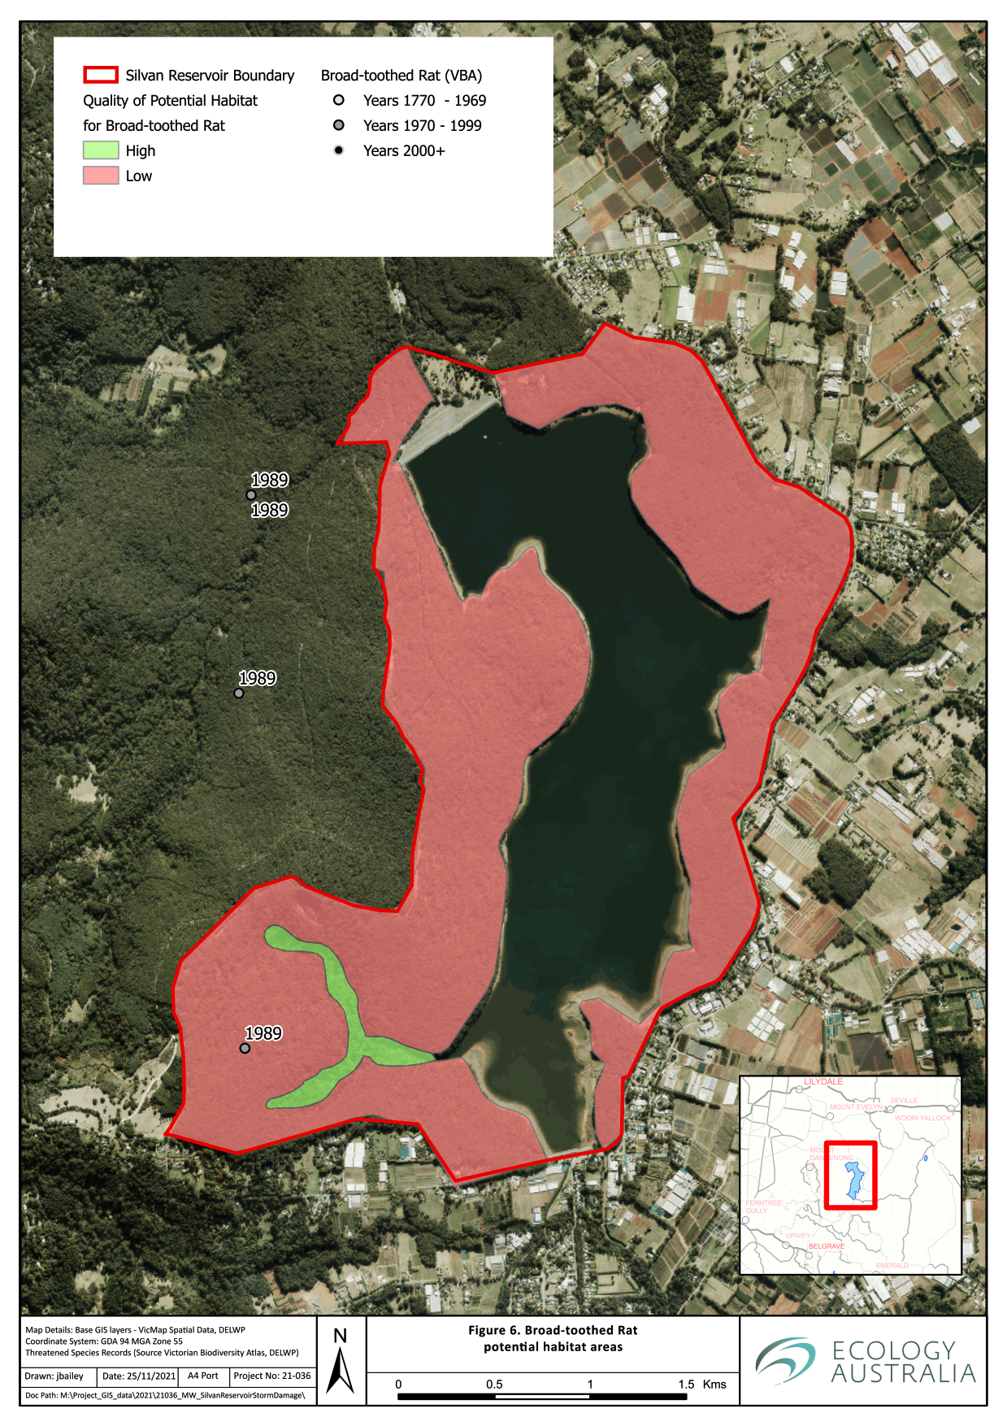
Figure 6 Broad-toothed Rat potential habitat areas.

Southern Greater Glider (Vulnerable – EPBC Act)

Species ecology, local habitat information and threats
The Southern Greater Glider (Greater Glider), which is the largest gliding possum (head and body: 350–450 mm, tail: 450–600 mm, and weight: 900–1700 g), is mostly folivorous with a diet comprised mostly of eucalyptus leaves (McKay 1995). They favour older, mixed stands of sclerophyll forests ranging from low, open woodlands and forests within coastal regions to tall wet forests at higher altitudes (~ 1200 m), on fertile soils, where both suitable hollow-bearing and foraging trees are present; this usually occurs within gullies and slopes with higher moisture (Menkhorst 1995). The Greater Glider has preferences for several species of canopy trees; to capitalise on foraging opportunities within foliage that has seasonal variation (Menkhorst 1995). Preferred eucalypt species for foraging include Mountain Ash, which occurs throughout the site, in addition to Narrow-leaf Peppermint, Manna Gum (Eucalyptus viminalis), and Blue-gum (Eucalyptus globoidea) (Menkhorst 1995). Eucalypts that readily form hollows, but may not necessarily be prime foraging habitat, include Mountain Grey Gum and Messmate Stringybark (Menkhorst 1995).
This species has been observed in the Dandenong Ranges National Park near Silvan Reservoir, including at least two recent records in 2021 (see Figure 7).
Due to the species having a limited dispersal ability through fragmented forests, and having relatively small home ranges, (1–4 ha in highly productive forests, and up to 14 ha in low productivity forest and woodlands), their distribution is limited to where patches of suitable habitat occur (Menkhorst 1995). For populations to persist, it is essential to ensure protection of trees with larger hollows (> 5 cm diameter entrance; Gibbons and Lindenmayer 2002), and to allow forests to senesce. Consideration of the impacts of fire location, frequency, and intensity, particularly for prescribed burns, is essential to ensure that suitable hollows and canopy extent for foraging and shelter, remains (Menkhorst 1995). Greater Glider is clumsy in its movements and is vulnerable to predation by foxes when on the ground (McKay 1995). The risk of this may be increased where there is fragmentation between suitable trees and/or habitat patches.

Significant Impact Criteria Assessment
The proposed log removal and remediation of the storm damaged areas is not likely to have a significant impact on the Greater Glider, as detailed in Table 9, below.

Table 9 EPBC Act Significant Impact Criteria addressed for Southern Greater Glider
Criterion | Response | Mitigation Actions
Lead to a long-term decrease in the size of a population | Unlikely. Very little is known about the extant status of the Dandenong Ranges population of this species as the species is rarely observed or surveyed. As a precaution, the areas that meet the requirements as suitable habitat for this species are areas where they are presumed potentially present. This project will not interfere directly with the identified habitat of the species. | The habitat within the major storm damaged areas is generally no longer suitable for Greater Glider. With the loss of canopy cover and greatly reduced connectivity, with few standing trees present to permit easy gliding distances, the sites are currently unsuitable for this species for foraging and movement,  The project will put protection measures in place to avoid the removal of or disturbance to potential habitat trees, particularly adjacent to the areas where large machinery will be used.
Reduce the area of occupancy of the species.  Is there a net reduction and/or diversity of suitable habitat to an important population? | Unlikely. The level of occupancy across the site is not currently known. The forest type throughout the western side of Silvan Reservoir and the adjoining Dandenong Ranges Park does provide suitable feeding habitat.  The forest gully area to the south-west of the Silvan Reservoir is of higher quality habitat, where there appears to be a greater number of very large trees with suitable hollows, with corresponding dense canopy-cover and mixed eucalypt species present. This project would not involve the removal of any potential high-quality habitat and suitable buffers of these areas will be in place, to avoid impacts within these areas.  In other areas, of lower quality habitat, minimisation of impacts will be implemented by remediation works avoiding the removal of standing dead trees, or living trees with hollows, unless they pose a safety issue. | Ensure the storm damage remediation works are restricted to outside of the forest gully habitats.  Protect large trees (dead or alive) including those with hollows, and only remove standing dead trees if they pose a safety issue.
Fragment an existing population in two or more populations  Is there removal or alteration of available corridors?  Is there any construction of physical barriers to movement such as roads or buildings? | Unlikely. With the protection and isolation of remediation works away from the potential high quality habitat areas there will be minimal additional fragmentation pressure put on any population that may be present. Corridors will remain in place in areas minimally affected by storm damage, in addition to retention of any standing trees which are deemed safe within storm affected areas. | Ensure the storm damage remediation works are restricted to outside of the potential high-quality habitat for this species on site.
Adversely affect habitat critical to the survival of the species | Unlikely. The only potential temporary impact would be to potential medium-quality habitat, which would be most likely utilised for dispersal, rather than significantly used for foraging or shelter, however, the species is relatively mobile where canopy trees are present and such impacts are unlikely to be significant if suitable movement corridors persist within the site and adjoining areas. | Ensure the storm damage remediation works are restricted to outside of the potential high-quality habitat for this species on site and maximise retention of standing trees (alive or dead) in the storm-damaged areas.
Disrupt the breeding cycle of a population | Unlikely. No removal of breeding habitat is planned. The loss of a large number of trees in the storm damage areas has reduced the likelihood of Greater Glider using these areas for breeding. Remediation works focused on protecting standing trees and encouraging natural regeneration will allow for it to become foraging habitat in the future. | Ensure the storm damage remediation works are restricted to outside of the potential habitat for this species on site and maximise retention of standing trees (alive or dead) in the storm-damaged areas.
Modify, destroy, remove, isolate, or decrease the availability or quality of habitat to the extent that the species is likely to decline | Unlikely. Although connectivity between some habitat patches, within the broader landscape may be reduced in the medium term, the minimal habitat removal or degradation is unlikely to be significant enough to lead to a decline in the species | Ensure the storm damage remediation works are restricted to outside of the potential habitat for this species on site and maximise retention of standing trees (alive or dead) in the storm-damaged areas.
Result in invasive species that are harmful to a critically endangered or endangered species becoming established in the endangered or critically endangered species habitat | Unlikely. No habitat degradation or removal will occur in the areas of potential high-quality habitat and minimal degradation will occur in the dispersal habitat. The spread of opportunistic exotic flora into these areas is unlikely to result from the planned construction works. Predators such as foxes and cats are unlikely to be influenced by this project. | Implement appropriate hygiene procedures for machinery, vehicles, soil, and rock importation that is consistent with Melbourne Water’s Pest Plant, Animal and Pathogen Guidelines (Melbourne Water 2012) and the Code of Practice for Timber Production (DELWP 2021).
Introduce disease that may cause the species to decline | Unlikely. | Implement appropriate hygiene procedures for machinery, vehicles, soil, and rock importation that is consistent with Melbourne Water’s Pest Plant, Animal and Pathogen Guidelines (Melbourne Water 2012) and the Code of Practice for Timber Production (DELWP 2021).
Interfere with the recovery of the species | Unlikely.

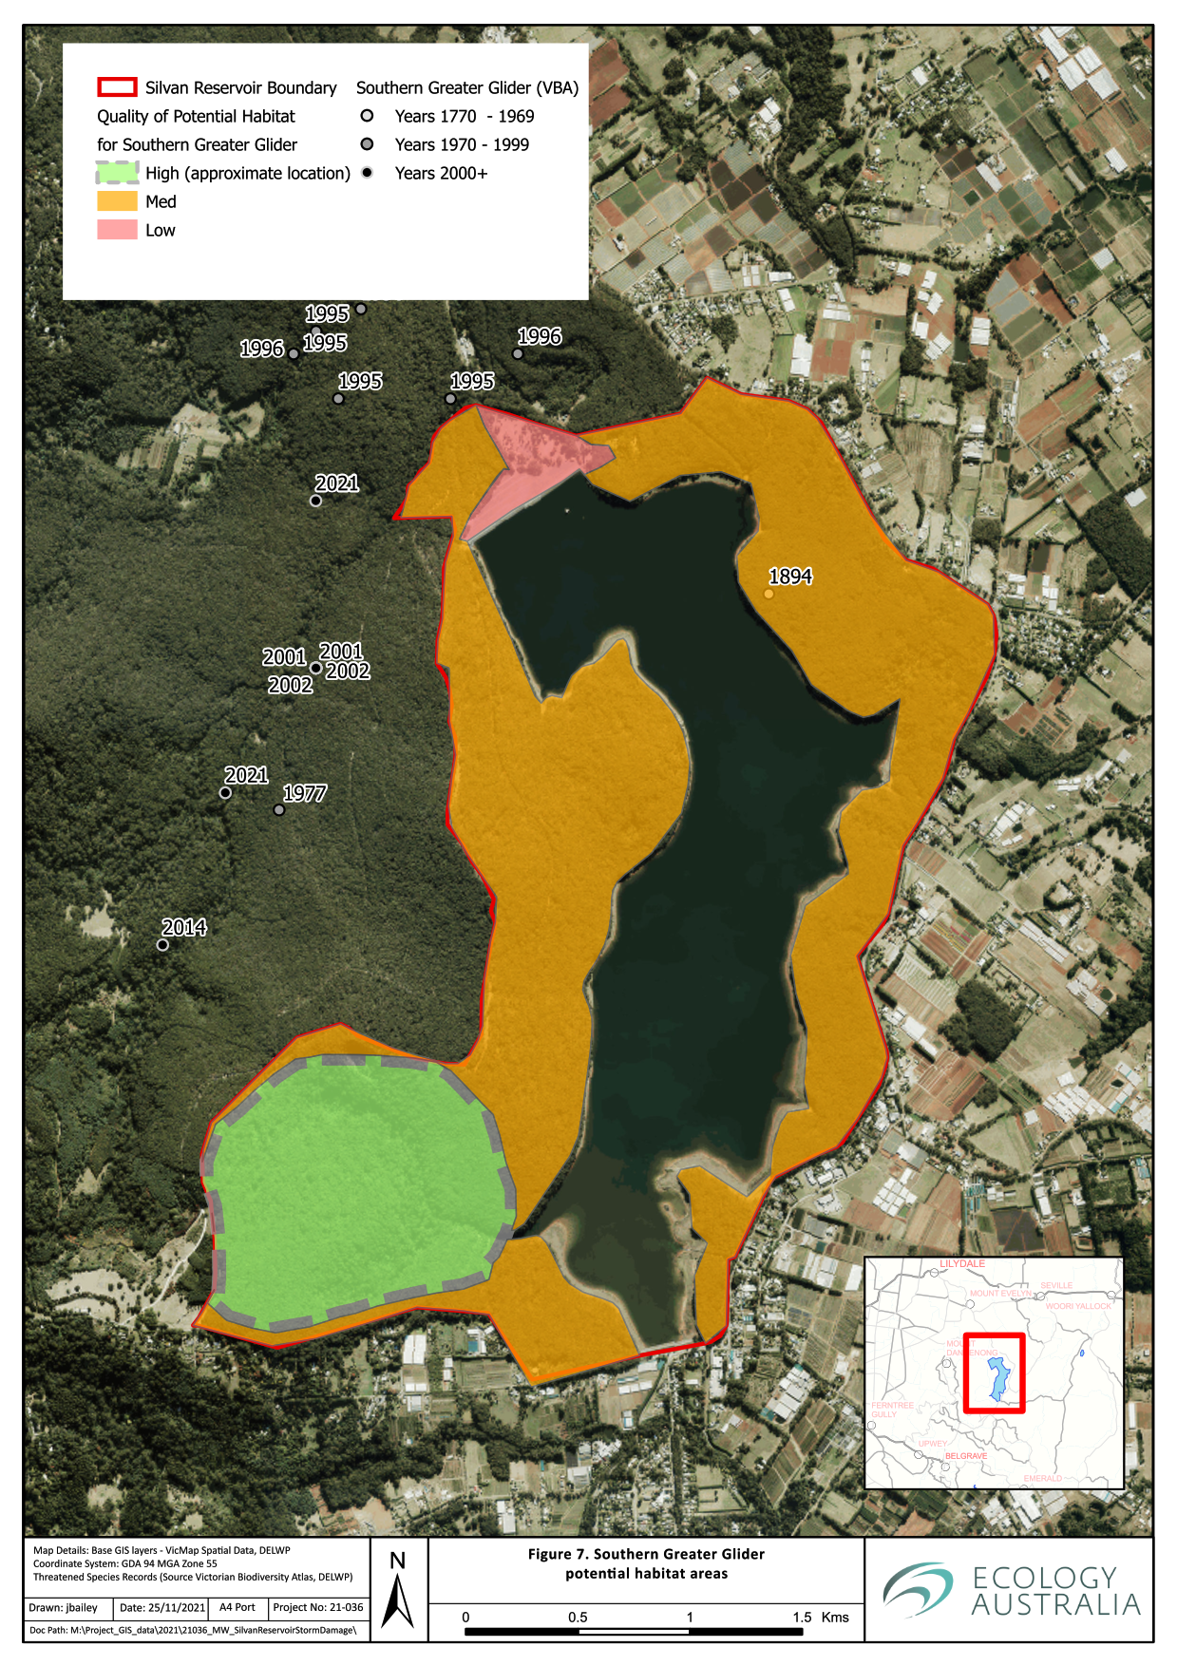
Figure 7 Southern Greater Glider potential habitat areas.

Risk Assessment of significant protected Flora and Fauna under the FFG Act
The FFG Act (1988) lists flora and fauna species and ecological communities that are recognised to be threatened in Victoria. It also identifies threatening processes (e.g. loss of hollow-bearing trees) and flora that require protection (i.e. protected flora). Protected flora includes those species listed as threatened under the FFG Act, plant taxa that belong to listed communities, and plant taxa that are not threatened but require protection for other reasons (e.g. from over-collection). A permit is required to remove protected flora from public land.
Silvan Reservoir is located on freehold land managed by Melbourne Water. As Melbourne Water is a public authority, it has obligations under the FFG Act to consider potential biodiversity impacts when exercising their functions.
There are several flora species that are not listed as threatened but are identified as protected flora under the FFG Act and could be impacted inadvertently through the log removal and remediation activities (Table 10).
Table 10 Species found at Silvan Reservoir, listed under the protected flora controls of the FFG Act.
Scientific Name | Common Name | Notes
Acacia mucronata subsp. longifolia | Narrow-leaf Wattle | Small patches or scattered individuals
Acacia stricta | Hop Wattle | Small patches or scattered individuals
Acacia verticillata | Prickly Moses | Scattered individuals
Acrotriche serrulata | Honey-pots | Quite common across the site
Adiantum aethiopicum | Common Maidenhair | Quite common across the site
Bedfordia arborescens | Blanket Leaf | Scattered individuals
Blechnum spp. | Water Fern | Common in damp or wet gullies in South-west of the site
Caladenia transitoria | Eastern Bronzehood Orchid | Scattered individuals
Calochlaena dubia | Common Ground-fern | Quite common across the site
Cassinia aculeata subsp. aculeata | Common Cassinia | Quite common across the site
Chiloglottis valida | Common Bird-orchid | Quite common across the site
Cryptostylis subulata | Large Tongue-orchid | Scattered individuals
Cyathea australis | Rough Tree-fern | Small patches or scattered individuals
Epacris impressa | Common Heath | Small patches or scattered individuals
Gleichenia spp. | Coral Fern | In the Wet Gully in the South-west
Lagenophora spp. | Bottle Daisy | Quite common across the site
Olearia argophylla | Musk Daisy-bush | Scattered individuals
Olearia lirata | Snowy Daisy-bush | Quite common across the site
Prostanthera lasianthos | Victorian Christmas-bush | Scattered individuals
Senecio spp. | Groundsel | Scattered individuals
Sigesbeckia orientalis subsp. orientalis | Indian Weed | Scattered individuals
Stylidium graminifolium s.l. | Grass Triggerplant | Quite common across the site
Xanthorrhoea minor subsp. lutea | Small Grass-tree | Small patches or scattered individuals
Xerochrysum bracteatum | Golden Everlasting | Small patches or scattered individuals

There are 15 threatened fauna species under the FFG Act that are known to be present or have a moderate or high likelihood of occurrence at Silvan Reservoir, three critically endangered: Barking Owl, Dandenong Freshwater Amphipod and Dandenong Burrowing Crayfish. Seven species are endangered: Sherbrooke Amphipod, Foothill Burrowing Crayfish (Engaeus victoriensis), Tubercle Burrowing Crayfish, White Bellied Sea-eagle, Sooty Owl, Lace Monitor and Grey Goshawk (Accipiter novaehollandiae) (Table 11). Two species of threatened flora species under the FFG Act that were seen within the site are detailed below, both are endangered: Powelltown Correa (Correa reflexa var. lobata) and Victorian Flat-pea (Platylobium reflexum).
A number of these species have their core habitats in the wet gully areas that are to be excluded from the log removal treatments, including Sooty Owl, Sherbrooke Amphipod, Dandenong Freshwater Amphipod and Dandenong Burrowing Crayfish.
Key threatened fauna species under the FFG Act have been grouped by their similar habitat requirements to provide detail on the habitat protection and mitigation strategies to avoid any significant impacts on them.

Burrowing crayfish – Engaeus spp.
Burrowing crayfish (Engaeus spp.) generally use their large (relative to their body size) claws to burrow to at times very substantial depths underground. Burrowing crayfish burrows are not usually directly connected to permanent streams, and they can be connected to, or independent of, groundwater (Horwitz and Richardson 1986). The burrows generally have excavated chambers of different heights above the groundwater to allow for fluctuations in water depth. The structure and depth of burrows varies substantially between species. Chimney-like structures are created with mud pellets by burrowing crayfish at the surface entrance or exit. It is these chimneys that are usually readily observed, as observations of burrowing crayfish individuals typically only occurs during wet conditions and is unusual during daylight hours (Bryant et al. 2009).
There is a high degree of endemism between burrowing crayfish species that have restricted ranges that appear to be influenced by poor dispersal ability, low fecundity, slow maturation, and habitat fragmentation (Bryant et al, 2012). However, there are considerable knowledge gaps in the distribution of burrowing crayfish species, primarily due to their cryptic and primarily subterranean habitats that have made effective surveys labour intensive. This issue is now being addressed by the use of eDNA sampling of downstream receiving waters to detect burrowing crayfish in the catchment (T Raadik, personal communication, 2021).
There are two species of burrowing crayfish that have historical records at Silvan Reservoir, Foothill Burrowing Crayfish and Tubercle Burrowing Crayfish. There is however a moderate to high likelihood of two other species being present at the site including Dandenong Burrowing Crayfish and Granular Burrowing Crayfish (Engaeus cunicularius) (D Crowther, personal communication, 2021), see Figure 8.
Dandenong Burrowing Crayfish is only active at night, spending daylight hours underground. However, this species has only been subject to limited research. They feed on organic matter that is decomposing such as leaves and dead roots. They will also feed on worms and insects (Horwitz 1985). This species has only been found in good quality, upper catchment streams where there are very limited stormwater inputs (Danger and Walsh 2008). They are found in the Wet Forest and Cool Temperate Rainforest vegetation types of the Dandenong Ranges, on the sandy soil flats adjacent to slow moving streams (DELWP 2015).
The Tubercle Crayfish co-occurs with the Dandenong Burrowing Crayfish, however, they occupy banks and hill slopes and have burrows that are independent of the groundwater, instead relying on surface water runoff (DELWP 2015).
Foothill Burrowing Crayfish are found in different habitats in clay-dominated soils in wet sclerophyll forests of the Dandenong Ranges (Crandall 2001). This species will dig very deep burrow systems as they are typically in habitat where the groundwater is not close to the surface (D Crowther, personal communication, 2021).
The Granular Burrowing Crayfish, which is not listed as threatened under the FFG Act, can be found in similar habitats to the Foothill Burrowing Crayfish (D Crowther, personal communication, 2021).
The distinctive burrow ‘chimneys’ of burrowing crayfish were observed all throughout the site (Figure 8).

Amphipods – Austrogammurus spp.
There are five Austrogammurus species found in Victoria, all of which are recorded east of Melbourne. There are two threatened species that occur in and near to the Dandenong Ranges, Dandenong Freshwater Amphipod (Austrogammurus australis) and Sherbrooke Amphipod (Austrogammurus haasei).
The Dandenong Freshwater Amphipod lives on the underside of coarse particulate organic matter including leaves and bark, and most likely uses this habitat for both shelter and food. Kerr (2003) showed that there was a positive correlation in presence and abundance with increased amount of organic litter within a stream reach, and that the species is light-sensitive and, therefore, could be outcompeted by other amphipod species where there is a more open canopy and lack of instream cover such as leaf litter (Kerr 2003). Wallaby and Lyrebird Creeks in the upper reaches of the Olinda Creek catchment are the main known locations for this species.
The Sherbrooke Amphipod is even less studied than the Dandenong Freshwater Amphipod. It is mainly known to be found in Sherbrooke Creek and in Hardy and Clematis Creeks, which are small upper tributaries of Monbulk Creek. This species inhabits creek lines with dense native vegetation and a closed canopy. Like the Dandenong Freshwater Amphipod, this species is expected to require a high level of instream native organic matter and low rates of sedimentation.
The Stoneyford Creek headwater stream located within the Silvan Reservoir closed catchment, has not previously been surveyed for either of these species. Ecology Australia collected samples of an Amphipod species (species identification is still pending final expert verification of species identification by D Crowther, Arthur Rylah Institute, as of 30/11/2021). during the site visit and rapid survey conducted as part of this study. The high-quality Wet Forest and Cool Temperate Rainforest vegetation at this site suggest that there is a moderate to high likelihood that one or both species good be found at this site (D Crowther, personal communication, 2021), see Figure 8.

Large forest owl species – Sooty Owl and Powerful Owl
The Powerful Owl occupies forested areas of the Great Dividing Range from central Queensland to the Victorian – South Australian border (Higgins 1999). Powerful Owls generally prefer older forests where large trees provide nesting sites and arboreal prey items are abundant, but resident breeding pairs are also known to occur in lower density residential areas (i.e. in the outer suburbs of Melbourne) (McNabb 1996, Cooke et al. 2002, Webster et al. 1999). Powerful Owls mostly prey upon nocturnal arboreal mammals and roosting diurnal birds (McNabb 1996, Cooke et al. 1997, Higgins 1999, Webster et al. 1999). They breed in large tree hollows, often using a small number of hollows (e.g. one to three) over many years, where breeding adults show extreme site fidelity (Higgins 1999). Estimates of the size of Powerful Owl territories or home range varies between 300–4000 ha (McNabb 1996, Silveira 1997, Webster et al. 1999, Soderquist et al. 2002). The large territory size is necessary to maintain prey resources. In south-east Australia, the Powerful Owl’s most common prey items include Eastern Ringtail Possums Pseudocheirus peregrinus and Krefft’s Glider Petaurus notatus (Cooke et al. 2002a). Powerful Owls roost during the day, among dense foliage in trees and shrubs. Large trees with dense canopy and sub-canopy foliage provide these important top predators with roosting sites sheltered from the elements. It can also assist in avoiding detection by day-active bird species, some of which will mob and harass owls when detected. Powerful Owls generally roost in the top one-third of trees, but they also adjust roost height in relation to ambient air temperature. A structurally heterogeneous habitat with vegetation of varying heights is therefore important to allow the Powerful Owl to find adequate roosting sites in areas with substantial temperature variation throughout the year (Cooke et al. 2002b).
The Sooty Owl and Powerful Owl both require large hollows to nest. The Sooty Owl is generally found within wet forest and gully vegetation whereas the Powerful Owl will occupy a larger range of habitat types. Sooty Owls tend to be associated with senescent forest where they tend to roost and nest in dead tree hollows (Loyn et al. 2002).

Powelltown Correa – Correa reflexa var. lobata
The Powelltown Correa is endemic to Victoria and found to east of Melbourne, generally between the Dandenong Ranges and Powelltown (VicFlora 2021). It is locally common in its natural distributional area, associated with moist, open-heathy or open-forest habitats. This species has previously been recorded at several locations within Silvan Reservoir and some additional records of this species were documented as part of the surveys undertaken for this project (Figure 5).
There is inadequate data to determine establishment conditions required for this species after fire. Adult plants generally respond as a ‘re-sprouter’ after a fire event, depending on the severity of the fire. It is thought that a second fire within five years could lead to the decline of the species at that site (Cawson and Muir 2008).
This species, if present within the storm damaged areas, is likely to be able to re-sprout after the ground disturbance from the remediation works.
Known locations of this species at the site should be protected from inadvertent damage from machinery during remediation works with temporary fencing.

Victorian Flat-pea – Platylobium reflexum
The Victorian Flat-pea is a common plant in tall wet forests east of Melbourne and in the Otways (VicFlora 2021). This species was observed as being quite common across large areas of the site during the current survey (Figure 5). These locations do not represent the complete distribution of this species across the site, as a targeted survey was not conducted. However, its distribution across the site seemed to correspond with areas that have had fire disturbance in the last decade or so. This is consistent with other species from this genus, as it produces hard-coated seeds that can remain dormant in the soil until fire or mechanical disturbance cracks the hard coat, triggering germination.

Orchids
Orchids are a protected taxon under the FFG Act. The Common Bird-orchid (Chiloglottis valida) was commonly encountered across all the surveyed areas with locations shown on the map in Figure 5. Other species that were observed in low numbers during the survey included Eastern Bronzehood Orchid (Caladenia transitoria) and Large Tongue-orchid (Cryptostylis subulata). The remediation works is likely to cause some temporary damage to these species from inadvertent trampling from heavy machinery. However, these species should be able to reproduce via seed or vegetatively, and the existing populations are unlikely to be significantly affected in the medium- to long-term.
The only threatened orchid species listed under the FFG Act that may be present on the western side of the Silvan Reservoir is Mountain Bird-orchid (Chiloglottis jeansii). If present, this species is most likely to be found in the wet forested gully areas in the south-west corner, an area that is going to be excluded from remediation works.

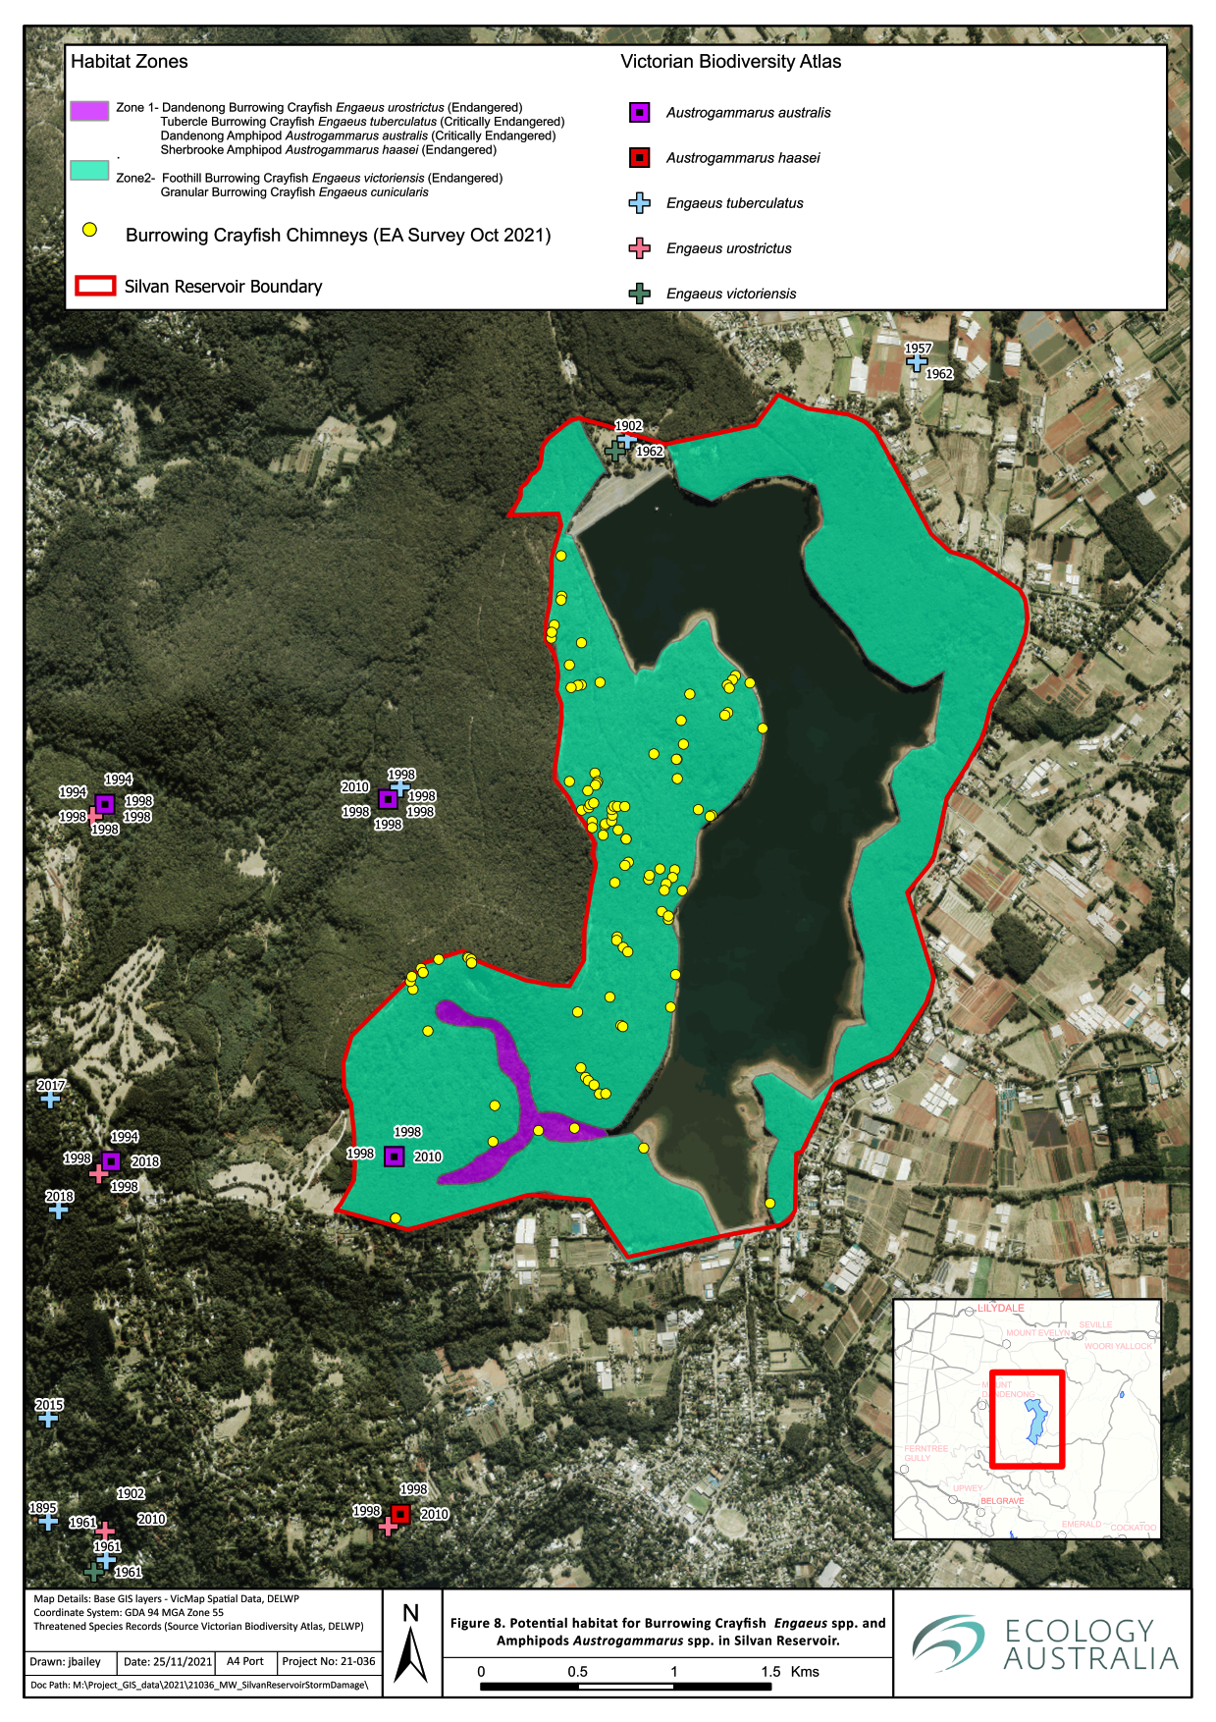

Figure 8 Potential habitat for threatened burrowing crayfish (Engaeus spp.) and amphipods (Austrogammurus spp.) at Silvan Reservoir.

Table 11 Likelihood of significant impact from the proposed storm damage remediation works on threatened fauna species under the FFG Act.
Scientific Name | Common Name | EPBC | Mi | Ma | FFG Category of Threat | FFG Extinction Risk | Source | No. of Records | Last Record | Likelihood of occurence | Likelihood Significant Impact
Hieraaetus morphnoides | Little Eagle |  |  |  | Vulnerable | Victoria | VBA | 16 | 2018 | High | Low
Tyto tenebricosa | Sooty Owl |  |  |  | Endangered | Victoria | VBA | 88 | 2019 | High | Low
Accipiter novaehollandiae | Grey Goshawk |  |  |  | Endangered | Victoria | VBA | 11 | 2019 | High | Low
Austrogammarus australis | Dandenong Freshwater Amphipod |  |  |  | Critically Endangered | Victoria | VBA | 47 | 2011 | High | Low
Engaeus tuberculatus | Tubercle Burrowing Crayfish |  |  |  | Endangered | Australia | VBA | 16 | 2019 | High | Low
Engaeus urostrictus | Dandenong Burrowing Crayfish |  |  |  | Critically Endangered | Australia | VBA | 15 | 2019 | High | Low
Engaeus victoriensis | Foothill Burrowing Crayfish |  |  |  | Endangered | Australia | VBA | 6 | 2011 | High | Low
Ninox strenua | Powerful Owl |  |  |  | Vulnerable | Victoria | VBA | 140 | 2019 | High | Low
Austrogammarus haasei | Sherbrooke Amphipod |  |  |  | Endangered | Victoria | VBA | 2 | 1999 | Moderate | Low
Spatula rhynchotis | Australasian Shoveler |  |  |  | Vulnerable | Victoria | VBA | 1 | 2018 | Moderate | Low
Aythya australis | Hardhead |  |  |  | Vulnerable | Victoria | VBA | 1 | 1987 | Moderate | Low
Lophoictinia isura | Square-tailed Kite |  |  |  | Vulnerable | Victoria | VBA | 1 | 2018 | Moderate | Low
Ninox connivens | Barking Owl |  |  |  | Critically Endangered | Victoria | VBA | 3 | 2004 | Moderate | Low
Ornithorhynchus anatinus | Platypus |  |  |  | Vulnerable | Victoria | VBA | 55 | 2021 | Low | Low
Varanus varius | Lace Monitor |  |  |  | Endangered | Victoria | VBA | 14 | 2019 | Moderate | Low

Table 12 Likelihood of significant impact from the proposed storm damage remediation works on threatened flora species under the FFG Act.
Scientific Name | Common Name | EPBC | FFG Category of Threat | FFG Extinction Risk | Source | Number of Records | Last Record | Likelihood of occurrence | Likelihood of significant impact
Correa reflexa var. lobata | Powelltown Correa |  | Endangered | Australia | VBA | 11 | 2017 | Known  (2021) | Low
Corybas aconitiflorus | Spurred Helmet-orchid |  | Endangered | Victoria | VBA | 3 | 2006 | High | Low
Platylobium reflexum | Victorian Flat-pea |  | Endangered | Australia | VBA | 1 | 1902 | Known  (2021) | Low
Platylobium infecundum | Famine Flat-pea |  | Critically Endangered | Australia | VBA | 1 | 2014 | Moderate | Low
Billardiera scandens s.s. | Velvet Apple-berry |  | Endangered | Victoria | VBA | 5 | 2009 | Moderate | Low
Chiloglottis jeanesii | Mountain Bird-orchid |  | Vulnerable | Australia | VBA | 7 | 2004 | Moderate | Low
Caladenia oenochila | Wine-lipped Spider-orchid |  | Critically Endangered | Victoria | VBA | 13 | 2012 | High | Not likely
Cyathea cunninghamii | Slender Tree-fern |  | Critically Endangered | Victoria | VBA | 11 | 2013 | High | Not likely
Abrodictyum caudatum | Jungle Bristle-fern |  | Endangered | Victoria | VBA | 2 | 2015 | High | Not likely
Acacia stictophylla | Dandenong Wattle |  | Endangered | Australia | VBA | 19 | 2019 | High | Not likely
Carex alsophila | Forest Sedge |  | Endangered | Australia | VBA | 4 | 2010 | High | Not likely
Lastreopsis hispida | Bristly Shield-fern |  | Endangered | Victoria | VBA | 4 | 1994 | High | Not likely
Tmesipteris parva | Small Fork-fern |  | Endangered | Victoria | VBA | 5 | 2015 | High | Not likely
Beyeria lanceolata | Pinkwood |  | Endangered | Victoria | VBA | 8 | 2017 | Moderate | Not likely
Prasophyllum lindleyanum | Green Leek-orchid |  | Endangered | Victoria | VBA | 1 | 2007 | Moderate | Not likely
Pteris epaleata | Netted Brake |  | Endangered | Victoria | VBA | 5 | 1980 | Moderate | Not likely

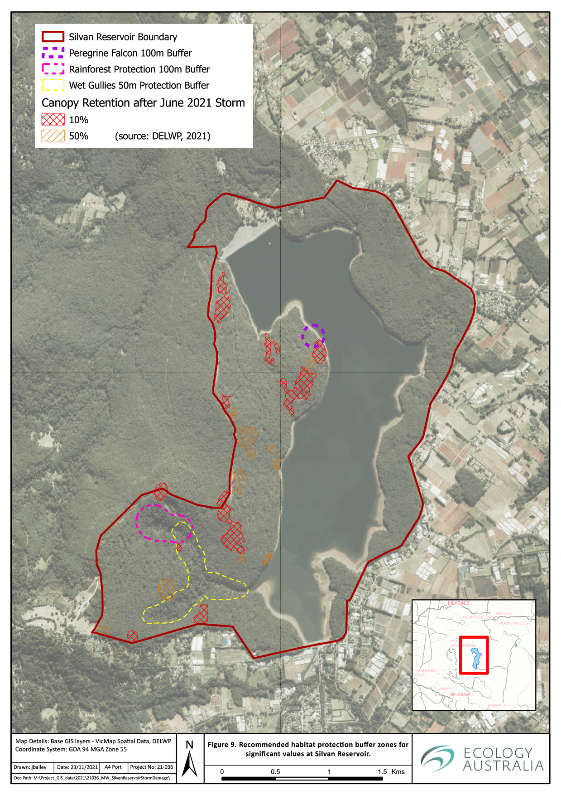
Figure 9 Recommended habitat protection buffer zones for significant values at Silvan Reservoir.

Recommendations
The following recommendations are provided to minimise vegetation loss and protect the biodiversity values of the site:
- Incorporate mitigation measures into a Construction Environment Management Plan (or equivalent) to ensure there is no significant impact on the following Matters of National Environmental Significance:
Broad-toothed Rat
Southern Greater Glider
White-bellied Sea-Eagle
- Incorporate mitigation measures into a Construction Environment Management Plan (or equivalent) to ensure there is no significant impact on threatened flora and fauna listed under the FFG Act:
Dandenong Freshwater and Sherbrooke Amphipods
Burrowing crayfish species
Large Forest Owls – Sooty, Powerful and Barking
Lace Monitor
Raptors – Square-tailed Kite, Little Eagle and Grey Goshawk
Cool Temperate Rainforest and Cool Temperate Mixed Forest communities
Powelltown Correa
Flat-pea species
- Where feasible, protect tree ferns and patches of juvenile trees (> 4 metres high) or tall shrubs from machinery and fire disturbance within the log removal areas
- Protect the Cool Temperate Rainforest by implementing a no-disturbance buffer of 100 m from the edge
- Protect the significant fauna values of the wet gully habitats in the south-west of the site with the widest possible buffer from the Wet Forest and Riparian Scrub vegetation communities (see Figure 9, on previous page). Multiple threatened species are reliant on late successional vegetation for habitat in these locations and protection of the area from soil disturbance is critical to their protection. Buffers should be a minimum of 50 metres only when a larger buffer cannot be achieved, based on safety or other management constraints (e.g. boundary fences, management tracks etc.)
- Protect identified nesting sites of bird species such as Peregrine Falcon (known location, see Figure 9) from noise or high impact disturbance during the breeding season (June–December) with a 100 m radius protection zone
- Protect White-bellied Sea-Eagle nests (if found) with a 100 m radius protection zone and exclude all high disturbance activities during the breeding season (1 May to 31 December)
- Protect Wedge-tailed Eagle nests (if found) with a 100 m radius protection zone and exclude all high disturbance activities during the breeding season (1 July to 30 November)
- Protect Square-tailed Kite (if found) with a 100 m radius protection zone and exclude all high disturbance activities during the breeding season (June–December)
- Sooty Owl nesting or roosting sites (if found) should have timber harvesting operations, road construction and burning excluded within a 250–300 m radius during the breeding season (March–October). If a roost or nesting site is not found, then the buffer of the Cool Temperate Rainforest and Wet Gully specifications should provide adequate protection (see Figure 9).
- Powerful Owl nesting sites (if found) should have timber harvesting operations, road construction and burning excluded within a 250–300 m radius during the breeding season (April–September)
- Log removal works should not occur when there is high soil moisture, to minimise the risk of mortality on burrowing crayfish that are more likely to be active in the top layer of the soil or on the surface during wet weather.
- Do not excavate or deep rip the soil, to avoid the risk of destroying burrowing crayfish burrow chambers.
- Should any burrow ‘chimneys’ of burrowing crayfish be identified by field staff (e.g. machine operators) during works, then attempts should be made to avoid driving over and blocking the ‘chimney’ with compacted earth. If any deceased burrowing crayfish are found by field staff, then if these should be collected and be placed in a sealed container, labelled and preserved in ethanol or methylated spirits. These samples are then to be submitted to Ecology Australia or Arthur Rylah Institute for identification purposes.
- After the log removal and prior to the fuel reduction (regeneration) burn, the presence of burrowing crayfish chimneys should be more visible and disturbance to them, during any additional earthworks or fire planning activities, should avoided or minimised
- Protect the rootzones of the trees that remain on the edges of the areas where log removal and fuel reduction burns are to be conducted. Plan operations to minimise any compaction within the tree protection zones of the edge trees. A minimum of ten metres buffer on the edge of the log removal areas with the intact forest should be managed to reduce the risk of soil compaction or other root disturbance. Avoid creation of temporary roading or ‘log landing sites’ within this zone.
- Ensure any areas for protection are clearly delineated as ‘no-go’ or ‘special management’ zones and that all field staff and machine operators are aware of all required mitigation actions to protect biodiversity in the relevant plans
- Plan the use of machinery to minimise the number of tight changes of direction with tracked vehicles to minimise the level of soil disturbance
- Maximise retention of hollow-bearing logs across the site where possible
- Develop and implement a regeneration program for the areas subject to log removal. Establish regeneration targets relating to cover and diversity of indigenous plant species and life-forms that mimic the natural early succession for the relevant Ecological Vegetation Division (EVD).
- This regeneration program is to contain monitoring and contingency management actions to ensure targets are met within a two- or three-year maintenance period.
- A review of the site-specific Fuel Management Plan should be conducted, to ensure future fuel management burns in the treated areas are managed (i.e. longer duration between fire), to allow eucalypt regeneration to get to a growth stage where survival of an appropriate cover can occur post burn, or subsequent fire treatments. This is critical to enable a long-term plan to replace tree canopy cover across the Silvan Site of Biodiversity Significance (SOBS).
Review of the Fire Management Plan should be conducted alongside the current SOBS management plan to ensure a consistent management approach.
- Should a new roost or nest site of a significant species be identified that is located less than the appropriate buffer distance from the proposed works, then the site should be inspected by a competent zoologist or ornithologist, prior to commencement of log removal or fuel reduction burn treatments; subsequently, appropriate recommendations should be developed in consultation with Melbourne Water and the contractor to guide appropriate site-specific mitigation measures.
- Ensure a thorough protocol is outlined in the Construction Environment Management plan to mitigate the risk of the spread weeds, pest, and pathogens, with a particular focus on Root-Rot Fungus (Phytophthora cinnamomi) and the Frog Chytrid Fungus (Batrachochytrium dendrobatidis). The project protocol should be consistent with Melbourne Water’s Pest Plant, Animal and Pathogen Guidelines (Melbourne Water 2021).
- Ensure appropriate procedures are in place to avoid any risk of contaminants entering sensitive gully lines, the unnamed headwater stream of Stoneyford Creek, and other waterbodies including the reservoir itself. These should be included in the CEMP and regularly checked for compliance.

References
Bryant, D., Crowther, D. and Papas, P. (2012) Improving survey methods and understanding the effects of fire on burrowing and spiny crayfish in the Bunyip and South Gippsland catchments. Project No. 17 of the “Rebuilding Together” funded by the Victorian and Commonwealth Governments Statewide Bushfire Recovery Plan. Victorian Government Department of Sustainability and Environment, Melbourne.
Cawson J. and Muir A. (2008) Flora monitoring protocols for planned burning: a user’s guide. Fire and Adaptive management Report no. 74. Department of Sustainability and Environment, East Melbourne.
Cheal, D. (2010) Growth stages and tolerable fire intervals for Victoria’s native vegetation data sets. Fire and Adaptive Management Report No. 84. Department of Sustainability and Environment, East Melbourne, Victoria, Australia.
Cooke, R., Wallis, R. and Webster, A. (2002a). Urbanisation and the ecology of powerful owls (Ninox strenua) in outer Melbourne, Victoria. In: Olsen J., Newton, I., Kavanagh R. and Taylor I. (2002). Ecology and conservation of owls. pp 100 – 106. CSIRO Publishing.
Cooke R., Wallis R. and White J. (2002b). Use of vegetative structure by powerful owls in outer urban Melbourne, Victoria, Australia – Implications for management. Journal of Raptor Researh, 36(4), 294-299 http://hdl.handle.net/10536/DRO/DU:30001535
Crandall, K.A. (2001) Engaeus victoriensis Smith and Schuster 1913. Version 01 January 2001 (under construction) http://tolweb.org/Engaeus_victoriensis/7853/2001.01.01 in The Tree of Life Web Project, http://tolweb.org/
DEPI (2013) Dandenong Ranges Landscape Bushfire Project- understanding the Hazard and Risk. Department of Environment and Primary Industries.
DELWP (2015) Dandenong Burrowing Crayfish Engaeus urostrictus. Action Statement No.264 Flora and Fauna Guarantee Act 1988. Department of Environment, Land, Water and Environment: Melbourne
DELWP (2017) Guidelines for the removal, destruction or lopping of native vegetation. Department of Environment, Land, Water and Environment, Melbourne
DELWP (2020a) Victorian Biodiversity Atlas database. Available at http://www.depi.vic.gov.au/environment-and-wildlife/biodiversity/victorian-biodiversity-atlas
DELWP (2020b) NatureKit database. Available at maps.biodiversity.vic.gov.au/viewer/?viewer=NatureKit
DELWP (2020c) Native Vegetation Information Management system. Available at: https://nvim.delwp.vic.gov.au/
DELWP (2021) Joint Fuel Management Program 2021/22 – 2023/2024, Port Phillip Region FFMVic Region, North West (D14), North East (D13) & South East (D08) CFA regions. Victorian Government Department of Environment, Land, Water and Planning.
DAWE (2013) Matters of National Environmental Significance: Significant Impact Guidelines 1.1. (Department of Agriculture, Water and the Environment: Canberra)
DAWE (2020) EPBC Act Protected Matters Search Tool. Available at: http://www.environment.gov.au/epbc/protected-matters-search-tool
DTPLI (2020) Victoria’s Planning Schemes Online. Available at: http://planningschemes.dpcd.vic.gov.au/
Gibbons, P. and Lindenmayer, D. (2002) Tree Hollows and Wildlife Conservation in Australia. CSIRO Publishing, Collingwood, Victoria
Happold, D.C.D (1995) In: The Mammals of Australia – revised edition (Ed. Strahan, R.), pp. 562-564, Reed Books, Chatswood, NSW.
Horwitz P.H.J. and Richardson A.M.M (1986) An Ecological Classification of the Burrows of Australian Freshwater Crayfish. Australian Journal of Marine and Freshwater Research 37, 237-242.
Higgins, P.J. (Ed.) (1999). Handbook of Australian, New Zealand and Antarctic Birds. Volume 4 Parrots to Dollarbird. (Oxford University Press, Melbourne.)
Kerr D. (2004) Factors affecting the distribution, and abundance of an endangered freshwater amphipod (Austrogammurus australis). Unpublished Honors Thesis.
Loyn R., McNabb E.G., Volodina L. and Willig R. (2001) Modelling distributions of large forest owls as a conservation tool in forest management: a case study from Victoria, southeastern Australia IN Ecology and Conservation of Owls (2002), Editors Newton I., Kavagnagh R., Olsen J. and Taylor I. CSIRO Publishing.
Melbourne Water (2017) Drinking Water Quality Strategy, Melbourne Water.
McKay, G.M. (1995) In: The Mammals of Australia – revised edition (Ed. Strahan, R.), pp. 240-241, Reed Books, Chatswood, NSW.
Menkhorst, P. W. Ed. (1995) Mammals of Victoria, Distribution, ecology and conservation, Oxford University Press, Melbourne.
Whisson, Desley A., Holland, Greg J. and Kelly, Thomas R. (2015) Persistence of a threatened species in a modified alpine resort environment: the Broad-toothed Rat. Journal of Mammalogy 96(1) pp. 151-158

Glossary
Biodiversity | The variety of all life-forms, plants, animals, fungi, protists (including algae) and bacteria, their encoded genes, and the ecosystems of which they form a part
Bioregion | Defined geographical regions of Australia with similar climatic and geophysical characteristics, and which generally contain a suite of distinct ecosystems and species
CaLP Act | Victorian Catchment and Land Protection Act 1994
Conservation status | Categorisation of the threat risk to biological assets (plant and animal species, EVCs or plant communities) at a defined scale (e.g. national, state), as determined by specific criteria
Ecological Vegetation Class (EVC) | A vegetation classification described through a combination of its floristic composition, life form and ecological characteristics, and its association with particular environmental attributes. EVCs may include one or more floristic communities that occur across a biogeographic range, and have similar habitat and ecological processes operating
Endemic | Naturally found only in a defined geographic area
EPBC Act | Commonwealth Environment Protection and Biodiversity Conservation Act 1999
Exotic | Plants, animals, fungi and other organisms that have been introduced (deliberately or accidentally) to Australia or a given area after European settlement
Exotic vegetation | Vegetation comprised wholly or substantially of exotic species
FFG Act | Victorian Flora and Fauna Guarantee Act 1988
Floristic | Of or pertaining to plant species, i.e. flora
GIS | Geographic Information System. A digital platform for creating, analysing and viewing maps and other spatially referenced data
Habitat Hectares | A measure of the quality and extent of native vegetation, incorporating attributes including presence of large trees, tree canopy health, understorey structure and diversity, weed cover and landscape context
High threat weeds | Introduced species (including non-indigenous ‘natives’) which, as invading species have highly deleterious impacts on indigenous vegetation and faunal habitats
Indigenous | Native plant and animal species found naturally in the geographic area of interest
Indigenous vegetation | Native vegetation found naturally in the geographic area of interest
Introduced | Deliberately or accidentally brought to Australia or part of Australia, usually by human agency
Life form | An abbreviated description of the habit, growth form and longevity of a plant species (e.g. tree, shrub, vine, annual, submerged aquatic)
Native vegetation | Vegetation occurring naturally in Australia pre-European settlement
Vegetation community | Term for interacting plant populations forming vegetation. A vegetation community in formal classifications may have characteristic plant species, composition and structure
VROTS | Victorian Rare or Threatened Species
WONS | Weeds of National Significance
Appendix 1 Vascular plant species recorded during the site assessments
Key: * – Exotic species C – Controlled weed species P – Protected flora (FFG Act)

* | Scientific Name | Common Name | Status
 | Acacia dealbata | Silver Wattle
 | Acacia melanoxylon | Blackwood
 | Acacia mucronata subsp. longifolia | Narrow-leaf Wattle | P
 | Acacia stricta | Hop Wattle | P
 | Acacia verticillata | Prickly Moses | P
 | Acaena novae-zelandiae | Bidgee-widgee
 | Acrotriche serrulata | Honey-pots | P
 | Adiantum aethiopicum | Common Maidenhair | P
 | Amperea xiphoclada var. xiphoclada | Broom Spurge
 | Asperula conferta | Common Woodruff
 | Banksia marginata | Silver Banksia
 | Bauera rubioides | Wiry Bauera
 | Bedfordia arborescens | Blanket Leaf | P
 | Billardiera mutabilis | Common Apple-berry
 | Blechnum cartilagineum | Gristle Fern | P
 | Brachyscome diversifolia | Tall Daisy | P
 | Bursaria spinosa | Sweet Bursaria
 | Caladenia transitoria | Eastern Bronzehood Orchid | P
 | Calochlaena dubia | Common Ground-fern | P
 | Carex sp. | Sedge
 | Cassinia aculeata subsp. aculeata | Common Cassinia | P
 | Chiloglottis valida | Common Bird-orchid | P
 | Clematis aristata | Mountain Clematis
 | Comesperma ericinum | Heath Milkwort
 | Comesperma volubile | Love Creeper
 | Coprosma quadrifida | Prickly Currant-bush
 | Correa reflexa var. lobata | Powelltown Correa | Endangered P
 | Cryptostylis subulata | Large Tongue-orchid | P
 | Cyathea australis | Rough Tree-fern | P
 | Dianella revoluta var. revoluta s.l. | Black-anther Flax-lily
 | Dianella tasmanica | Tasman Flax-lily
 | Diplazium australe | Austral Lady-fern
 | Drosera auriculata | Tall Sundew
 | Epacris impressa | Common Heath | P
 | Eucalyptus baxteri | Brown Stringybark
 | Eucalyptus cypellocarpa | Mountain Grey-gum
 | Eucalyptus obliqua | Messmate Stringybark
 | Eucalyptus ovata | Swamp Gum
 | Eucalyptus radiata subsp. radiata | Narrow-leaf Peppermint
 | Exocarpos cupressiformis | Cherry Ballart
 | Gahnia sieberiana | Red-fruit Saw-sedge
 | Geranium potentilloides | Soft Crane's-bill
 | Geranium sp. | Crane's Bill
 | Gleichenia microphylla | Scrambling Coral-fern | P
 | Gonocarpus humilis | Shade Raspwort
 | Gonocarpus tetragynus | Common Raspwort
 | Goodenia humilis | Swamp Goodenia
 | Goodenia lanata | Trailing Goodenia
 | Goodenia ovata | Hop Goodenia
 | Hackelia latifolia | Forest Hound's-tongue
 | Hakea decurrens subsp. physocarpa | Bushy Needlewood
 | Hovea heterophylla | Common Hovea
 | Hydrocotyle sp. | Pennywort
 | Hypericum gramineum | Small St John's Wort
 | Kunzea sp. | Kunzea
 | Lagenophora sp. | Bottle Daisy | P
 | Lepidosperma laterale | Variable Sword-sedge
 | Leptospermum continentale | Prickly Tea-tree
 | Leptospermum lanigerum | Woolly Tea-tree
 | Lindsaea linearis | Screw Fern
 | Lomandra filiformis | Wattle Mat-rush
 | Lomandra longifolia | Spiny-headed Mat-rush
 | Lomatia ilicifolia | Holly Lomatia
 | Luzula sp. | Woodrush
 | Melaleuca ericifolia | Swamp Paperbark
 | Microlaena stipoides var. stipoides | Weeping Grass
 | Notelaea ligustrina | Privet Mock-olive
 | Olearia argophylla | Musk Daisy-bush | P
 | Olearia lirata | Snowy Daisy-bush | P
 | Olearia ramulosa var. ramulosa | Twiggy Daisy-bush | P
 | Opercularia sp. | Stinkweed
 | Oxalis spp. | Wood Sorrel
 | Pandorea pandorana subsp. pandorana | Wonga Vine
 | Pimelea axiflora | Bootlace Bush
 | Pimelea flava | Yellow Rice-flower
 | Pimelea ligustrina | Tall Rice-flower
 | Pittosporum bicolor | Banyalla
 | Platylobium reflexum | Victorian Flat-pea | Endangered
 | Poa sp. | Tussock Grass
 | Polyscias sambucifolia subsp. 1 | Broad-leaf Panax
 | Polyscias sambucifolia subsp. 3 | Mountain Panax
 | Polystichum proliferum | Mother Shield-fern | P
 | Pomaderris aspera | Hazel Pomaderris
 | Poranthera microphylla | Small Poranthera
 | Prostanthera lasianthos | Victorian Christmas-bush | P
 | Pteridium esculentum subsp. esculentum | Austral Bracken
 | Pultenaea forsythiana | Prickly Bush-pea
 | Pultenaea gunnii | Golden Bush-pea
 | Pultenaea scabra | Rough Bush-pea
 | Ranunculus plebeius s.l. | Forest/Hairy Buttercup
 | Rubus parvifolius | Small-leaf Bramble
 | Schoenus apogon | Common Bog-sedge
 | Senecio linearifolius var. denticulatus | Fireweed Groundsel (eastern variant) | P
 | Senecio sp. | Groundsel | P
 | Sigesbeckia orientalis subsp. orientalis | Indian Weed | P
 | Solanum prinophyllum | Forest Nightshade
 | Spyridium parvifolium | Dusty Miller
 | Stackhousia monogyna s.s. | Creamy Candles
 | Stellaria spp. | Starwort
 | Stylidium graminifolium s.l. | Grass Triggerplant | P
 | Tetrarrhena juncea | Forest Wire-grass
 | Tetratheca ciliata | Pink-bells
 | Veronica plebeia | Trailing Speedwell
 | Viola betonicifolia subsp. betonicifolia | Showy Violet
 | Viola hederacea | Ivy-leaf Violet
 | Xanthorrhoea minor subsp. lutea | Small Grass-tree | P
 | Xerochrysum bracteatum | Golden Everlasting | P
* | Acer pseudoplatanus | Sycamore Maple
* | Anthoxanthum odoratum | Sweet Vernal-grass
* | Centaurium erythraea | Common Centaury
* | Cerastium glomeratum s.l. | Common Mouse-ear Chickweed
* | Cirsium vulgare | Spear Thistle | C
* | Erigeron sp. | Fleabane
* | Galium murale | Small Goosegrass
* | Hedera hibernica | Atlantic Ivy
* | Lysimachia arvensis | Pimpernel
* | Ilex aquifolium | English Holly
* | Myosotis arvensis | Field Forget-me-not
* | Pittosporum undulatum | Sweet Pittosporum
* | Prunella sp. | Self-heal
* | Prunus laurocerasus | Cherry Laurel
* | Ranunculus repens | Creeping Buttercup
* | Rubus anglocandicans | Common Blackberry | C
* | Sambucus nigra | Common Elder
* | Senecio jacobaea | Ragwort | C

Appendix 2 Significant Flora species recorded within 5 km of the site and their likelihood of occurrence
Key : EPBC Act: CR – Critically endangered, EN – Endangered, VU – vulnerable, FFG Act: L – listed as threatened; N – nominated for listing as threatened
Scientific Name | Common Name | EPBC | FFG Category of Threat | FFG Extinction Risk | Source | Number of Records | Last Recorded | Likelihood of occurrence
Abrodictyum caudatum | Jungle Bristle-fern |  | Endangered | Victoria | VBA | 2 | 3/03/2015 | High
Acacia stictophylla | Dandenong Wattle |  | Endangered | Australia | VBA | 19 | 13/11/2019 | High
Amphibromus fluitans | River Swamp Wallaby-grass | VU |  |  | PMST | NA | NA | Not likely
Beyeria lanceolata | Pinkwood |  | Endangered | Victoria | VBA | 8 | 9/11/2017 | Moderate
Billardiera scandens s.s. | Velvet Apple-berry |  | Endangered | Victoria | VBA | 5 | 24/11/2009 | Moderate
Botrychium australe | Austral Moonwort |  | Critically Endangered | Victoria | VBA | 1 | 20/05/1909 | Low
Caladenia flavovirens | Christmas Spider-orchid |  | Critically Endangered | Victoria | VBA | 5 | 7/12/1980 | Moderate
Caladenia oenochila | Wine-lipped Spider-orchid |  | Critically Endangered | Victoria | VBA | 13 | 25/09/2012 | High
Caladenia vulgaris | Slender Pink-fingers |  | Vulnerable | Victoria | VBA | 2 | 19/12/1998 | Low
Carex alsophila | Forest Sedge |  | Endangered | Australia | VBA | 4 | 5/01/2010 | High
Chiloglottis jeanesii | Mountain Bird-orchid |  | Vulnerable | Australia | VBA | 7 | 23/11/2004 | High
Correa reflexa var. lobata | Powelltown Correa |  | Endangered | Australia | VBA | 11 | 14/02/2017 | High
Corybas aconitiflorus | Spurred Helmet-orchid |  | Endangered | Victoria | VBA | 3 | 12/05/2006 | High
Corybas grumulus | Mountain Helmet-orchid |  | Endangered | Victoria | VBA | 4 | 1/01/1945 | Moderate
Cyathea cunninghamii | Slender Tree-fern |  | Critically Endangered | Victoria | VBA | 11 | 1/07/2013 | High
Dianella amoena | Matted Flax-lily | EN | Critically Endangered | Victoria | PMST | NA | NA | Not likely
Diuris behrii | Golden Cowslips |  | Endangered | Victoria | VBA | 1 | 1/10/1901 | Not likely
Eucalyptus strzeleckii | Strzelecki Gum | VU | Critically Endangered | Australia | PMST | NA | NA | Not likely
Eucalyptus yarraensis | Yarra Gum |  | Critically Endangered | Victoria | VBA | 1 | 01/01/1770 | Not likely
Euphrasia collina subsp. muelleri | Purple Eyebright | EN | Endangered | Victoria | VBA | 1 | 1/09/1902 | Not likely
Gentianella polysperes | Early Forest-gentian |  | Endangered | Victoria | VBA | 3 | 23/11/1905 | Low
Glycine latrobeana | Clover Glycine | VU | Vulnerable | Victoria | PMST | NA | NA | Not likely
Grevillea parvula | Genoa Grevillea |  | Endangered | Victoria | VBA | 1 | 9/05/2000 | Low
Isolepis wakefieldiana | Tufted Club-sedge |  | Endangered | Victoria | VBA | 1 | 30/01/1907 | Low
Lastreopsis hispida | Bristly Shield-fern |  | Endangered | Victoria | VBA | 4 | 17/04/1994 | High
Macromitrium longirostre | Macromitrium |  | Critically Endangered | Victoria | VBA | 1 | 1/11/1950 | Not likely
Melaleuca armillaris subsp. armillaris | Giant Honey-myrtle |  | Endangered | Victoria | VBA | 1 | 24/05/2000 | Not likely
Orthrosanthus multiflorus | Morning Flag |  | Endangered | Victoria | VBA | 1 | 14/11/2007 | Not likely
Platylobium infecundum | Famine Flat-pea |  | Critically Endangered | Australia | VBA | 1 | 20/08/2014 | Moderate
Platylobium reflexum | Victorian Flat-pea |  | Endangered | Australia | VBA | 1 | 2021 (not yet in VBA) | High
Pomaderris vacciniifolia | Round-leaf Pomaderris | CR | Critically Endangered | Australia | PMST | NA | NA | Low
Prasophyllum lindleyanum | Green Leek-orchid |  | Endangered | Victoria | VBA | 1 | 16/10/2007 | Moderate
Pteris epaleata | Netted Brake |  | Endangered | Victoria | VBA | 5 | 21/03/1980 | Moderate
Pterostylis chlorogramma | Green-striped Greenhood | VU | Endangered | Victoria | PMST | NA | NA | Low
Pultenaea weindorferi | Swamp Bush-pea |  | Endangered | Victoria | VBA | 4 | 28/10/1941 | Low
Tmesipteris ovata | Oval Fork-fern |  | Endangered | Victoria | VBA | 1 | 01/01/1853 | Low
Tmesipteris parva | Small Fork-fern |  | Endangered | Victoria | VBA | 5 | 3/03/2015 | High
Xerochrysum palustre | Swamp Everlasting | VU | Critically Endangered | Victoria | PMST | NA | NA | Not likely

Appendix 3 Threatened fauna species recorded within 5 km of the site and their likelihood of occurrence
EPBC Act: CR – Critically endangered, EN – Endangered, VU – vulnerable, Mi – Migratory, Ma – Marine, FFG Act: L – listed as threatened; N – nominated
Scientific Name | Common Name | EPBC | Mi | Ma | FFG Category of Threat | FFG Extinction Risk | Source | Number of Records | Last Recorded | Likelihood of occurrence
Falco hypoleucos | Grey Falcon | VU |  |  | Vulnerable | Victoria | PMST | NA | NA | Not likely
Antechinus minimus maritimus | Swamp Antechinus | VU |  |  | Vulnerable | Victoria | PMST | NA | NA | Low
Grantiella picta | Painted Honeyeater | VU |  |  | Vulnerable | Victoria | PMST | NA | NA | Low
Litoria raniformis | Growling Grass Frog | VU |  |  | Vulnerable | Victoria | VBA, PMST | 5 | 7/12/1990 | Low
Pteropus poliocephalus | Grey-headed Flying-fox | VU |  |  | Vulnerable | Victoria | VBA, PMST | 2 | 1/04/1982 | Low
Hirundapus caudacutus | White-throated Needletail | VU | Mi | Ma | Vulnerable | Victoria | VBA, PMST | 38 | 24/02/2016 | High
Mastacomys fuscus mordicus | Broad-toothed Rat | VU |  |  | Vulnerable | Victoria | VBA, PMST | 20 | 15/07/1989 | Moderate
Petauroides volans | Southern Greater Glider | VU |  |  | Vulnerable | Victoria | VBA, PMST | 31 | 26/02/2021 | High
Maccullochella peelii | Murray Cod | VU |  |  | Endangered | Victoria | VBA | 1 | 1/01/1970 | Not likely
Prototroctes maraena | Australian Grayling | VU |  |  | Endangered | Victoria | PMST | NA | NA | Not likely
Galaxiella pusilla | Dwarf Galaxias | VU |  |  | Endangered | Australia | PMST | NA | NA | Low
Dasyurus viverrinus | Eastern Quoll | EN |  |  | Endangered (extinct in Vic) | Australia | VBA | 1 | 01/01/1880 | Not likely
Maccullochella macquariensis | Trout Cod | EN |  |  | Endangered | Victoria | VBA | 1 | 1/01/1970 | Not likely
Macquaria australasica | Macquarie Perch | EN |  |  | Endangered | Victoria | VBA | 1 | 01/01/1760 | Not likely
Pseudomys fumeus | Smoky Mouse | EN |  |  | Endangered | Victoria | PMST | NA | NA | Not likely
Dasyurus maculatus maculatus | Spot-tailed Quoll | EN |  |  | Endangered | Victoria | VBA, PMST | 1 | 16/10/1974 | Low
Isoodon obesulus obesulus | Southern Brown Bandicoot | EN |  |  | Endangered | Victoria | VBA, PMST | 8 | 12/09/2018 | Low
Rostratula australis | Australian Painted-snipe | EN | Mi |  | Critically Endangered | Victoria | PMST | NA | NA | Not likely
Botaurus poiciloptilus | Australasian Bittern | EN |  |  | Critically Endangered | Victoria | PMST | NA | NA | Low
Synemon plana | Golden Sun Moth | CR |  |  | Vulnerable | Victoria | VBA | 1 | 01/01/1760 | Not likely
Lichenostomus melanops cassidix | Helmeted Honeyeater | CR |  |  | Critically Endangered | Australia | VBA | 2 | 24/05/1994 | Not likely
Numenius madagascariensis | Eastern Curlew | CR | Mi | Ma | Critically Endangered | Victoria | PMST | NA | NA | Not likely
Lathamus discolor | Swift Parrot | CR |  | Ma | Critically Endangered | Victoria | VBA, PMST | 4 | 20/04/1976 | Low
Anthochaera phrygia | Regent Honeyeater | CR |  |  | Critically Endangered | Victoria | VBA, PMST | 8 | 3/03/1986 | Low
Calidris ferruginea | Curlew Sandpiper | CR | Mi | Ma | Critically Endangered | Victoria | PMST | NA | NA | Low
Stagonopleura guttata | Diamond Firetail |  |  |  | Vulnerable | Victoria | VBA | 1 | 9/12/1914 | Not likely
Pomatostomus temporalis | Grey-crowned Babbler |  |  |  | Vulnerable | Victoria | VBA | 4 | 30/08/1931 | Not likely
Ardea alba modesta | Eastern Great Egret |  | Mi |  | Vulnerable | Victoria | VBA | 6 | 14/07/2018 | Low
Lophoictinia isura | Square-tailed Kite |  |  |  | Vulnerable | Victoria | VBA | 1 | 15/09/2018 | Moderate
Ninox strenua | Powerful Owl |  |  |  | Vulnerable | Victoria | VBA | 140 | 26/12/2019 | High
Melanodryas cucullata | Hooded Robin |  |  |  | Vulnerable | Victoria | VBA | 3 | 22/12/1988 | Not likely
Calamanthus pyrrhopygius | Chestnut-rumped Heathwren |  |  |  | Vulnerable | Victoria | VBA | 3 | 8/01/2000 | Low
Aythya australis | Hardhead |  |  |  | Vulnerable | Victoria | VBA | 1 | 25/09/1987 | Moderate
Biziura lobata | Musk Duck |  |  | Ma | Vulnerable | Victoria | VBA | 7 | 19/06/2019 | Known
Actitis hypoleucos | Common Sandpiper |  | Mi | Ma | Vulnerable | Victoria | PMST | NA | NA | Low
Hieraaetus morphnoides | Little Eagle |  |  |  | Vulnerable | Victoria | VBA | 16 | 13/02/2018 | High
Spatula rhynchotis | Australasian Shoveler |  |  |  | Vulnerable | Victoria | VBA | 1 | 25/05/2018 | Moderate
Ixobrychus dubius | Australian Little Bittern |  |  |  | Endangered | Victoria | VBA | 1 | 26/12/1894 | Not likely
Lissolepis coventryi | Swamp Skink |  |  |  | Endangered | Victoria | VBA | 1 | 7/12/1990 | Not likely
Accipiter novaehollandiae | Grey Goshawk |  |  |  | Endangered | Victoria | VBA | 11 | 2/01/2019 | High
Austrogammarus haasei | Sherbrooke Amphipod |  |  |  | Endangered | Victoria | VBA | 2 | 20/05/1999 | Moderate
Egretta garzetta | Little Egret |  |  | Ma | Endangered | Victoria | VBA | 1 | 1/09/1976 | Low
Haliaeetus leucogaster | White-bellied Sea-Eagle |  | Mi | Ma | Endangered | Victoria | VBA, PMST | 3 | 1/01/2018 | Known
Pseudophryne bibronii | Brown Toadlet |  |  |  | Endangered | Victoria | VBA | 1 | 15/05/1943 | Low
Pyrrholaemus sagittatus | Speckled Warbler |  |  |  | Endangered | Victoria | VBA | 6 | 26/01/2000 | Low
Tyto tenebricosa | Sooty Owl |  |  |  | Endangered | Victoria | VBA | 88 | 17/10/2019 | High
Acrodipsas myrmecophila | Small Ant Blue Butterfly |  |  |  | Endangered | Victoria | VBA | 2 | 1/11/1912 | Not likely
Tringa nebularia | Common Greenshank |  | Mi | Ma | Endangered | Victoria | PMST | NA | NA | Not likely
Engaeus tuberculatus | Tubercle Burrowing Crayfish |  |  |  | Endangered | Australia | VBA | 16 | 25/07/2019 | High
Engaeus victoriensis | Foothill Burrowing Crayfish |  |  |  | Endangered | Australia | VBA | 6 | 19/05/2011 | High
Pseudophryne semimarmorata | Southern Toadlet |  |  |  | Endangered | Victoria | VBA | 4 | 28/04/1988 | Low
Pasma tasmanica | Two-spotted Grass-skipper Butterfly |  |  |  | Endangered | Victoria | VBA | 25 | 3/12/1949 | Low
Varanus varius | Lace Monitor |  |  |  | Endangered | Victoria | VBA | 14 | 6/11/2019 | Moderate
Pseudemoia rawlinsoni | Glossy Grass Skink |  |  |  | Endangered | Victoria | VBA | 1 | 21/12/1988 | Not likely
Austrogammarus australis | Dandenong Freshwater Amphipod |  |  |  | Critically Endangered | Victoria | VBA | 47 | 26/10/2011 | High
Engaeus urostrictus | Dandenong Burrowing Crayfish |  |  |  | Critically Endangered | Australia | VBA | 15 | 25/07/2019 | High
Ninox connivens | Barking Owl |  |  |  | Critically Endangered | Victoria | VBA | 3 | 2/09/2004 | Moderate
Apus pacificus | Fork-tailed Swift |  | Mi | Ma |  |  | PMST | NA | NA | Moderate
Calidris acuminata | Sharp-tailed Sandpiper |  | Mi | Ma |  |  | PMST | NA | NA | Low
Monarcha melanopsis | Black-faced Monarch |  | Mi | Ma |  |  | PMST | NA | NA | Low
Rhipidura rufifrons | Rufous Fantail |  | Mi | Ma |  |  | PMST | NA | NA | Low
Merops ornatus | Rainbow Bee-eater |  | Mi | Ma |  |  | PMST | NA | NA | Low
Myiagra cyanoleuca | Satin Flycatcher |  | Mi | Ma |  |  | PMST | NA | NA | Moderate
Pandion cristatus | Eastern Osprey |  | Mi | Ma |  |  | PMST | NA | NA | Low
Motacilla tschutschensis | Eastern Yellow Wagtail |  | Mi |  |  |  | PMST | NA | NA | Low
Chrysococcyx osculans | Black-eared Cuckoo |  |  |  |  |  | PMST | NA | NA | Not likely
Calidris melanotos | Pectoral Sandpiper |  | Mi | Ma |  |  | PMST | NA | NA | Low
Gallinago hardwickii | Latham's Snipe |  | Mi | Ma |  |  | PMST | NA | NA | Low
Accipiter fasciatus | Brown Goshawk |  |  | Ma |  |  | VBA | 88 | 1/04/2020 | High
Cacomantis flabelliformis | Fan-tailed Cuckoo |  |  | Ma |  |  | VBA | 130 | 29/09/2020 | Known
Coracina novaehollandiae | Black-faced Cuckoo-shrike |  |  | Ma |  |  | VBA | 78 | 1/12/2020 | Known
Corvus mellori | Little Raven |  |  | Ma |  |  | VBA | 208 | 15/10/2020 | Known
Falco cenchroides | Nankeen Kestrel |  |  | Ma |  |  | VBA | 6 | 20/05/2017 | Moderate
Grallina cyanoleuca | Magpie-lark |  |  | Ma |  |  | VBA | 236 | 1/02/2021 | Known
Haliastur sphenurus | Whistling Kite |  |  | Ma |  |  | VBA | 5 | 1/09/2017 | Moderate
Hirundo neoxena | Welcome Swallow |  |  | Ma |  |  | VBA | 173 | 12/09/2021 | Known
Coturnix pectoralis | Stubble Quail |  |  | Ma |  |  | VBA | 10 | 16/04/2018 | Low
Porzana pusilla | Baillon's Crake |  |  | Ma |  |  | VBA | 1 | 1/12/1911 | Not likely
Porphyrio melanotus | Australasian Swamphen |  |  | Ma |  |  | VBA | 2 | 25/09/1987 | Low
Pelecanus conspicillatus | Australian Pelican |  |  | Ma |  |  | VBA | 3 | 16/01/2018 | Low
Neophema chrysostoma | Blue-winged Parrot |  |  | Ma |  |  | VBA | 11 | 4/02/2019 | Known
Nycticorax caledonicus | Nankeen Night-Heron |  |  | Ma |  |  | VBA | 3 | 25/09/1987 | Low
Circus approximans | Swamp Harrier |  |  | Ma |  |  | VBA | 2 | 20/04/2018 | Low
Eurystomus orientalis | Oriental Dollarbird |  |  | Ma |  |  | VBA | 2 | 1/01/1975 | Not likely
Petroica phoenicea | Flame Robin |  |  | Ma |  |  | VBA | 17 | 5/05/2007 | High
Eurostopodus mystacalis | White-throated Nightjar |  |  | Ma |  |  | VBA | 1 | 12/10/1912 | Not likely
Petroica rodinogaster | Pink Robin |  |  | Ma |  |  | VBA | 10 | 23/09/2018 | High
Threskiornis spinicollis | Straw-necked Ibis |  |  | Ma |  |  | VBA | 22 | 1/12/2020 | Moderate
Todiramphus sanctus | Sacred Kingfisher |  |  | Ma |  |  | VBA | 30 | 5/02/2019 | Known
Acrocephalus australis | Reed-Warbler |  | Mi |  |  |  | VBA | 1 | 25/09/1987 | Low
Anthus australis | Australian Pipit |  |  | Ma |  |  | VBA | 7 | 1/01/1980 | Low
Zosterops lateralis | Silvereye |  |  | Ma |  |  | VBA | 236 | 29/09/2020 | Known
Bubulcus coromandus | Eastern Cattle Egret |  | Mi | Ma |  |  | VBA | 2 | 1/01/1975 | Low
Climacteris picumnus | Brown Treecreeper |  |  |  |  |  | VBA | 9 | 18/11/2018 | Low
Pseudalmenus chlorinda zephyrus | Silky Hairstreak Butterfly |  |  |  |  |  | VBA | 21 | 31/12/1976 | Not likely

